# POLITECNICO DI MILANO

# Scuola di Ingegneria Industriale e dell’Informazione

# Corso di Laurea Magistrale in Ingegneria Informatica



**REHABILITATION GAMES FOR**

**JUVENILE RHEUMATIC DISEASE**

**Relatore: Prof. Pier Luca Lanzi**

**Correlatore: Dott. Paolo Vercellesi**

**Correlatrice: Dr. Ft. Amalia Lopopolo**

**Tesi di Laurea di:**

**Rocco Michele Chiuri (M. 765493)**

**Anno Accademico 2013-2014**

*a mio zio Enzo*

# Sommario

La riabilitazione motoria è una terapia molto importante che può migliorare la qualità di vita di persone con funzionalità motorie limitate. Questo tipo di terapia viene svolta facendo eseguire ripetutamente al paziente una serie di semplici esercizi. È proprio questa monotonia una delle cause per cui alcuni pazienti che non sono costantemente sotto la supervisione dei fisioterapisti tendono a non eseguire con continuità gli esercizi o, addirittura, ad abbandonare la terapia. Da qui la necessità di trovare dei metodi alternativi che stimolassero il paziente a eseguire tali esercizi con continuità. È qui che entrano in gioco i *serious games*, i quali sfruttano la caratteristica fondamentale dei videogames, cioè il divertimento, per raggiungere uno scopo più utile, come, nel nostro caso, quello della riabilitazione.

In questa tesi esponiamo il nostro lavoro relativo alla progettazione di una serie di *exergames* (videogiochi che hanno come scopo quello dell’esercizio fisico) per aiutare pazienti affetti da *Artrite Idiopatica Giovanile* nel loro percorso riabilitativo. Ci siamo concentrati, in particolare, sulla riabilitazione dei polsi. Per il design dei nostri giochi abbiamo seguito la metodologia di *iterative design*, che consiste nel testare, analizzare e rifinire ciclicamente il prototipo del proprio progetto al fine di migliorare il prodotto finale. Il nostro obiettivo principale è stato quello di progettare e creare dei giochi che fossero soprattutto divertenti, invogliando così i pazienti a utilizzarli e quindi a eseguire la terapia motoria, ma allo stesso tempo utili ai fisioterapisti per l’analisi delle performance dei pazienti. Per fare ciò, ci siamo basati su un insieme di regole di game design, alcune generiche per la creazione di videogiochi, altre specifiche per i giochi che hanno come scopo la riabilitazione. Abbiamo così progettato quattro videogiochi, ciascuno di un genere diverso dall’altro per cercare di venire incontro ai gusti di un pubblico il più vasto possibile. Per ciascun gioco abbiamo progettato un gameplay il più intuitivo possibile, in modo da renderlo immediatamente fruibile dal paziente. Abbiamo inserito, inoltre, alcune caratteristiche che aumentassero l’interesse e l’impegno del paziente, come ad esempio il sistema di punteggi o la possibilità di adattare la difficoltà in base al proprio livello di abilità. Infine, abbiamo progettato una serie di caratteristiche che permettessero ai fisioterapisti di avere un feedback sia qualitativo che quantitativo relativamente alle performance dei pazienti. Questi feedback possono essere utili sia per valutare come il paziente svolge i propri esercizi quando è da solo, ad esempio a casa, sia per capire per quali tipologie di movimenti il paziente ha più bisogno di esercitarsi e quindi personalizzare maggiormente la terapia.

Con l’aiuto dei fisioterapisti e dei pazienti della clinica Pediatrica G. e D. de Marchi, abbiamo svolto delle sessioni di test in cui abbiamo raccolto i feedback sia degli uni che degli altri. In particolare le prime due sessioni sono state utili per validare quanto avevamo progettato, mentre nelle successive abbiamo analizzato come i pazienti interagivano con i giochi e come si adattavano ad essi con il susseguirsi delle partite. I feedback da parte sia dei pazienti che dei fisioterapisti sono stati positivi. I primi si sono divertiti testando i giochi e hanno rilasciato commenti positivi a riguardo, i secondi hanno apprezzato sia le funzionalità specifiche per il loro lavoro che avevamo inserito nei giochi, che la reazione dei pazienti ai giochi. In particolare il modo in cui i pazienti hanno svolto facilmente esercizi che durante le sessioni di terapia standard trovavano difficili.

# Abstract

One issue of the standard physical therapy used in the rehabilitation process is that patients tend to have problems in performing it regularly, due to the tediousness of repeating simple exercises. Thus it is important to find alternative ways of making physical therapy that would encourage patients to keep exercising. This thesis concerns the development of a set of rehabilitation games for children affected by *Juvenile Idiopathic Arthritis*. Focusing on the wrist rehabilitation we designed a set of four games. We diversified our gaming offer designing different kind of games in order to appeal a wider range of people. For the design of the games we used the iterative design approach, that is a cyclic process of prototyping, testing, analyzing and refining our games. The main goal was to design games that would entertain the patients encouraging them to play and so to perform their exercise, preventing them from quitting the physical therapy. We also designed some features that would help the therapists in analyzing the patients’ performances and progress and give some useful information about possible improvements in the therapy. With the help of a team of therapists and patients from Clinica Pediatrica G. e D. De Marchi we performed a set of experimental sessions in order to validate our designs and to analyze how the patients interacted and adapted to the games. Feedbacks were good from both the patients, who enjoyed playing the games, and the therapists, who were satisfied with the features that we designed and with the patients’ response to the games.

# *Ringraziamenti*

*Vorrei iniziare ringraziando il prof. Pier Luca Lanzi per la disponibilità mostrata in questi anni e in particolare nel periodo in cui è stato svolto il progetto per la tesi. Lo ringrazio anche per avermi spronato, a modo suo, quando ne avevo bisogno.*

*Ringrazio il dott. Paolo Vercellesi, che ha proposto e creduto in questo progetto. Un grazie anche ad Amalia Lopopolo e Michaela Foà per la loro disponibilità e ai pazienti della clinica G. e D. De Marchi che hanno partecipato ai test.*

*Un grazie particolare ai miei genitori, che con i loro sacrifici mi hanno permesso di raggiungere questo obiettivo. Ringrazio anche mio fratello e mia sorella per i consigli che mi hanno dato (anche se a volte non li ho seguiti) e per l’affetto che mi hanno dimostrato in questi anni.*

*Infine, grazie a tutti gli amici con cui ho condiviso il tempo (e a volte anche la casa (ciao Stefano, ciao Pamela)) da quando sono a Milano e a quelli storici di Tricase.*

*Beh, direi che è tutto.*

*Ah, giusto, dimenticavo, un grazie speciale ad Angela per essermi stata vicina in questi anni, per l’aiuto che mi ha dato nei momenti difficili, per come mi ha supportato in questi ultimi mesi un po’ stressanti, per tutte le cose buone che cucina, un po’ meno per i 10 kili che ho messo su da quando stiamo insieme, per la tranquillità che è riuscita a darmi e per tutto l’altro resto.*

# Contents

**Contents** **i**

**List of Figures** **iii**

**List of Tables** **vii**

**1 Introduction** **5**

**2 State of the art** **6**

2.1 Games for rehabilitation 6

2.2 Rehabilitation of upper limbs 10

2.2.1 Non-hands-free games 10

2.2.2 Hands-free games 12

**3 Juvenile Idiopathic Arthritis and Polyarthritis** **14**

3.1 Chronic arthritis in childhood 14

3.1.1 Etiopathogenesis and clinical manifestations 15

3.1.2 Treatment 18

3.2 Polyarthritis 19

3.3 Physical therapy 21

3.3.1 Wrist exercises 22

3.3.2 Other exercises 23

**4 Designing rehabilitation games for JIA** **26**

4.1 Designing rehabilitation games 26

4.2 Preliminary study and design 32

4.3 Main application and games 36

4.2.1 Rhythm game 40

4.2.2 Flappy bird-like game 41

4.2.3 Ski game 42

4.2.4 Plane simulator 43

**5 Testing and data analysis** **46**

5.1 Experimental setup 46

5.2 First experimental session 48

5.2.1 Tested game modes 49

5.2.2 Users’ feedback 49

5.2.3 Data analysis 50

5.2.4 Final remarks 58

5.2.5 Final remarks 59

5.3 Second experimental session 59

5.3.1 Tested game modes 60

5.3.2 Users’ feedback 60

5.3.3 Data analysis 61

5.3.5 Final remarks 69

5.4 Third experimental session 69

5.4.1 Tested game modes 70

5.4.2 Users’ feedback 70

5.4.3 Data analysis 70

5.4.4 Final remarks 76

**6 Conclusions and future work** **79**

**Bibliography** **80**

# List of figures

3.1 Wrist extension and flexion [21] 22

3.2 Wrist radial and ulnar deviation [21] 22

3.3 Tendon glides [22] 23

3.4 Thumb flexion/extension [22] 23

3.5 Thumb abduction/adduction [22] 24

3.6 Finger opposition [22] 24

3.7 Finger extension 1 [23] 24

3.8 Finger extension 2 [24] 25

4.1 Leap Motion Controller 33

4.2 LMC’s view of the hand 33

4.3 Leap Motion Diagnostic Visualizer 34

4.4 LMC right-handed coordinate system 34

4.5 Gestures recognized by the LMC 35

4.6 System architecture 37

4.7 Random path generator 37

4.8 Replay mode 38

4.9 Tuning session 38

4.10 Rhythm game 40

4.11 Flappy Bird-like game 41

4.12 Ski game 42

4.13 Plane simulator – two hands 44

4.14 Plane simulator – one hand 44

5.1 Experimental setup without the bolster 47

5.2 Experimental setup with the bolster 47

5.3 Experimental setup with the bolster and the orthoses 48

5.4 Experimental setup with the wedge and the orthoses 48

5.5 Performance of S2 playing to the flight simulator game 51

5.6 Performance of S2 playing to the flight simulator game 53

5.7 Performance of S3 playing to the flight simulator game without the bolster 54

5.8 Performance of S2 playing to the original mode of the Flappy Bird-like game 55

5.9 Performance of S3 playing to the original mode of the Flappy Bird-like game 55

5.10 Performances of S2 playing to the continuous movement mode of the Flappy Bird-like game 56

5.11 Performances of S3 playing to the continuous movement mode of the Flappy Bird-like game 57

5.12 Performance of S1 playing to the rhythm game 61

5.13 Performance of S2 playing to the rhythm game 61

5.14 First performance of S2 playing to the one hand mode of the flight simulator game 62

5.15 Second performance of S2 playing to the one hand mode of the flight simulator game 63

5.16 First performance of S2 playing to the two hand mode of the flight simulator game 64

5.17 Second performance of S2 playing to the two hand mode of the flight simulator game 65

5.18 Performance of S1 playing to the one hand mode of the flight simulator game 66

5.19 Performance of S1 playing to the two hand mode of the flight simulator game 67

5.20 Performance of S2 playing to the extension/flexion mode of the ski game 68

5.21 Performance of S2 playing to the deviation mode of the ski game 68

5.22 Performances of S1 playing to the continuous mode of the Flappy Bird-like game 71

5.23 Performances of S1 playing to the rhythm game 72

5.24 Performance of S1 playing to the two hands mode of the flight simulator 74

5.25 First performance of S1 playing to the one hand mode of the flight simulator 75

5.26 Second performance of S1 playing to the one hand mode of the flight simulator 76

5.27 Performance of S1 playing to the deviation mode of the ski game 77

5.28 Performance of S1 playing to the flexion/extension mode of the ski game 77

# List of tables

3.1 ILAR criteria for classification of chronic arthritis of childhood [19] 14

3.2 Characteristics of the Inflamed Joint 17

3.3 Extraarticular Manifestations 17

3.4 Objectives of the treatment of chronic arthritis in children [19] 18

3.5 RF-negative polyarthritis clinical manifestations 20

3.6 RF-positive polyarthritis clinical manifestations 20

# Chapter 1

Introduction

In recent years a new kind of videogames, called serious games, has become increasingly relevant. The core idea of serious games is mixing the entertaining factor typical of classic videogames with a useful purpose that helps the players acquiring new abilities or improving those that they already have. Serious games have been developed in several environments, for different purposes: there are educational games for learning purposes, games used for military training, games for healthcare, and much more.

In this work we focus on rehabilitation games or exergames (exercise games), i.e. those kind of games that help people with physical impairment to perform their physical therapy. Studies show [5] that the main issue with standard physical therapy is that, due to the monotony of the exercises, patients tend to lose interest in the therapy. As a consequence of this loss of interest, patients either perform their exercises irregularly or, in the worst case, quit the physical therapy. Since the aim of physical therapy is to help patients improving (or at least keeping stable) their physical functionality, either an early stopping of the therapy or not performing regularly the exercises can affect their quality of life and the ones of those who are close to them (e.g. their families). The introduction of new gaming input devices, such as Nintendo’s Wii Remote™ and Microsoft’s Kinect, that require the players to move more than their fingers in order to play a game and the subsequent development of games that involve physical activity, induced the researchers to consider the possibility of using videogames in order to perform physical therapy. Besides the hardware, a major aspect that led researchers to study a possible application of videogames in rehabilitation is the inherent ability of games to draw the player’s attention using a mix of entertainment and challenge. This aspect is really important in rehabilitation, since if a game encourages the patients to keep playing it, it will result in the patients performing regularly his physical therapy. Studies validated both the Wii Remote [9] and the Kinect [8] as suitable for the rehabilitation process and tested the effectiveness of some commercial games already developed [10-12]. This led to focus more on rehabilitation games. In particular, also considering the feedbacks of the therapists, were defined some game design rules [13] that a rehabilitation game should have. Those rules are a mix of classic game design rules that aim to design entertaining and challenging games and specific rules that validate the games as useful medical applications. We based on this set of rules to design our games.

We focused, in particular, on the hand rehabilitation of children affected by *Juvenile Idiopathic Arthritis* (JIA). JIA includes a set of rheumatoid diseases for which has not been defined a cause, yet. The main common symptom of this several types of arthritis is chronic joint inflammation. This inflammation begins before patients reach the age of sixteen and if the symptoms last from six weeks to three months, the disease is called chronic. JIA may involve one or many joints, and cause other symptoms such as fevers, rash and/or eye inflammation. A classification of six JIA onset types have been defined. *Systemic arthritis* affects the whole body and includes high fever, rash and inflammation of internal organs as symptoms. *Oligoarthritis* affects less than five joints. Symptoms include pain, stiffness or swelling in the joints. Also, an inflammation of the iris may occur. *Polyarthritis* affects five or more joints. *Psoriatic arthritis* consists of both arthritis and a skin disease called psoriasis or a family history of psoriasis in a parent or sibling. *Enthesitis-related arthritis* often involves attachments of ligaments as well as the spine. Children affected by this form of JIA may have joint pain without obvious swelling and suffer of back pain and stiffness. Finally, *Undifferentiated arthritis* includes syndromes that does not fit into any of the above categories or fit into more than one of the categories.

As said before, in this work we focused on the hand rehabilitation therapy, in particular on the exercises performed using the wrists. In order to do so we applied the iterative design approach, a methodology based on a cyclic process of prototyping, testing, analyzing, and refining of the games. We designed four different games following a set of both classical and specific game design rules. Our aim was to design a set of games that would be entertaining for everyone to play while helping patients performing their exercises. In order to do so, we designed different types of games, aiming to reach a wider range of people with different tastes and gaming background. In particular we designed four different types of game: a rhythm game, since games like Guitar Hero and similar proved this genre to be entertaining for a wide range of people; a casual game, similar to the famous Flappy Bird, that would appeal everyone with its simplicity and would serve as a virtual link to the other commercial non-medical games; a simple and intuitive arcade game, easy to play also for the younger patients; a 3D flight simulation game, that would provide a more mature experience, suitable also for older patients. We designed the gameplay of all the games to be as intuitive as possible. We wanted the patient to immediately understand how the game works and start playing It without tedious training sessions. In order to encourage the patient to focus on the performance, we added a scoring system that would function both as a visual feedback of the performance and as a reward for the correctness of the exercise. The possibility to compare the score between friends also adds a challenge factor that could encourage the patient to play more often and to focus even more on the game, resulting in more frequent and well-executed exercises. We also focused on the design of a set of helpful features for the therapists’ analysis. We designed both a quantitative and a qualitative feedback. The former comes in the form of data collected during each performance. This data can be used by the therapist in order to analyze how the patient performed in an exercise, see if the therapy is helping the patient making progress in terms of increasing of the wrists’ range of motion, and eventually modify the therapy focusing on specific movements. The qualitative feedback has been designed in the form of a replay mode that, using the data collected during an exercise, allows the therapist to see again how the patient performed the exercise in terms of physical positions of the hands. This feature is useful, for example, to see how the patients perform the exercises when they are at home without the supervision of a therapist.

Finally, following the iterative design approach mentioned before, we performed a series of experimental sessions with the help of some patients of the Clinica Pediatrica G. e D. De Marchi. The aim of the first to sessions was to validate our design. We presented the games both to the patients and to the subjects, and collected their feedback as the subjects tested the games. The feedbacks were overall good, the subjects enjoyed playing to the game and the therapists were satisfied with the specific features that we implemented for the analysis and with the subjects’ response. In particular they noted that the subjects were effortlessly performing exercises that they found boring during standard physical therapy. In the following experimental sessions we focused on how the subjects played to the games. We analyzed the data collected both in the form of hands’ positions during the exercises and scores in the relative games, in order to see how the subjects adapted to the games and which games required more or less effort with respect to the others.

The document is organized as follows.

*Chapter 2* is an overview of the games for rehabilitation. We discuss their aim, their features and present some developed games, focusing especially on those for hand rehabilitation.

In *Chapter 3* we present the *Juvenile Idiopathic Arthritis*, its causes, symptoms and treatment. We give a brief description of the polyarticular onset of JIA, since it is the one that is more likely to affect the hands. Finally, we present some exercises for hand rehabilitation.

*Chapter 4* is about the games that we designed. We discuss the rules that we applied for the design of the games and how we later implemented it in the final games.

In *Chapter 5* we analyze the data retrieved during the experimental sessions. We describe the experimental setup of each session, the feedback received from both the therapists and the subjects and we present and comment the plots relative to the data collected.

Finally, in *Chapter 6* we draw our conclusions and present possible future developments and improvements of our work .

# Chapter 2

State of the art

In this chapter we focus on serious gaming, in particular on the sub-genre specific for rehabilitation. We define what a serious game is and the process that led to the use of videogames for rehabilitation. Then we present some specific features and game design rules found in literature. Finally, we give an overview of the state of the art for hand rehabilitation games.

## 2.1 Games for rehabilitation

Rego et al. [1] define serious games as “games that allow the player to achieve a specific purpose using the entertainment and engagement component provided by the experience of the game”. This specific purpose could be either an educational one [2] or a training one (e.g. military training [3]) or it could concern health issues [4]. Focused on this last environment are the games for health. They can be useful in diagnostics, prevention, advertising, training, fitness, rehabilitation, relaxation, etc. In our case, we focused on rehabilitation games. The aim of this kind of game is to help people who have impaired physical functions – as a consequence of a disease or some other harmful events – to perform their physical therapy throughout the rehabilitation progress.

Physical therapy is essential for the treatment of disabling pathologies, either chronic or acute; it usually consists of a series of task specific exercises which must be repeated over and over by the patient. In order for the patient to improve his/her physical condition, or at least to keep it stable, this therapy must be performed frequently and for a long period of time, both at the hospital and (if it is possible) at home. The main issue with this approach is that patients tend to lose interest in doing repetitive exercises [5], compromising the effectiveness of the rehabilitation process. Indeed, patients find this repetitive exercises boring and frustrating, leading to a loss of motivation in keep performing the therapy. The issue worsen when the patients have to perform their exercises at home, without a therapist that supervises and encourages them.

The increasing popularity of videogames drew the attention of the researchers as a possible solution to this problem. Indeed, the success of videogames is due to their ability to entertain and engage people, motivating them to keep playing even for long periods of time. Researchers wanted to use this kind of engagement to encourage the patients to keep performing their therapy but, as they introduced virtual reality and videogames in the rehabilitation process, two limitations raised: the virtual reality systems were too expensive and the presence of technical experts was needed during therapy sessions [7]. This limitations prevented patients from performing the exercises whenever and wherever they wanted, thus affecting the regularity of the therapy.

The introduction of new input devices such as the Wii Remote, the Wii Balance Board, the EyeToy or the Kinect helped to overcome those limitations. Unlike classic controllers, these new devices required the players to move their whole body or part of it in order to play. The introduction of motion in playing proved to be entertaining for people [6]. Furthermore, the cost of the devices and their respective consoles (Nintendo Wii for the Wii Remote and Wii Balance Board, Sony Playstation 2 for the EyeToy and Microsoft Xbox 360 for the Kinect) was relatively cheap, making the games developed on these platforms more accessible. Studies were conducted that validated these instruments [8,9] as suitable for the rehabilitation process and tested the effectiveness of some off-the-shelf games (e.g Wii Sports [10], Wii Fit [11], EyeToy games [12]).

Off-the-shelf games proved to be not suitable for every patient because they require a speed and a range of movements that someone with physical impairment cannot easily perform [13]. Hence the need to develop custom games and to define specific game design rules that would help developers in designing such games.

Burke et al. [13] discuss some features that a rehabilitation game should have and propose a couple others:

* it should provide precise data recording, in order for the therapist to clearly evaluate the exercise execution;
* it should provide to the therapist some kind of feedback relative to the level of the exercise;
* it should provide feedback to the players in order to measure their performance and their progress;
* it should handle both the rewarding side (i.e. giving quantifiable advantages for completing tasks successfully) and the failure side (i.e. exposing a recognizable disadvantage for poor gameplay) of the game in a way that keeps the patient effectively engaged;
* it should be challenging (but not frustrating) for the patient, this could be achieved by statically (e.g. using a level structure) or dynamically (i.e. while playing) adapting the game difficulty according to the patient’s performances and abilities.

Borghese et al. [14] identify three key features in designing rehabilitation games: adaptation, monitoring, and real-time evaluation of the movements. The game should adapt its difficulty level to the abilities of the player, otherwise it would be either frustrating or tedious to play it. The performance of the player should be monitored, enforcing a correct execution of the rehabilitation movements. The player should receive feedbacks about his/her performance while playing, in order to understand when he/she is doing something wrong or right. Borghese et al. also remark the importance of designing rehabilitation games according to good game design principles in order to keep the player engaged. They state that “the patient, while exercising, should feel like a player, focused on having fun while playing the game”.

Nixon and Howard [31] define a set of five game design principles useful to create engaging rehabilitation games. The first principle regards the in-game story. They say that an engaging story or context is crucial when trying to draw players into a play scenario. Also important is to design a user interface that is intuitive and easy to understand, since the player’s concentration should be geared to how to beat the game, not how to learn its interface. Like Burke and Borghese, also Nixon and Howard remark the importance of providing immediate feedback to the player about something right or something wrong that he did while playing. Furthermore the game should encourage the player to explore and become familiar with his/her capabilities within the game; this helps the player gaining better control over his/her avatar. Finally, the player should be rewarded in order to keep him/her engaged in the game and to encourage him/her to play again, increasing his/her skills in order to get better rewards.

Mader et al. [32] assert that two fundamental features to the game designer’s work are challenge and variability. These aspects are tightly related to the design of a therapeutic game. In order to keep the player motivated, the game has to inform him of his progression towards the goal. Also adapting the challenge level prevents anxiety or boredom in the player. Variability accounts for the motivation in the long run. As Mader et al. state “it is not enough to give the player the same task with an adapted difficulty level, we must also make him learn new patterns, gather new informations, explore the consequences of making different choices”.

Mader et al. also propose a model to evaluate a therapeutic game. This model is based on three entities (the game, the therapy and the player) and on the relations between them. Starting from the therapy-player relation it is necessary to assess if the player has a particular condition that can be improved by the therapy. Then should be evaluated what is the context of play (e.g. at home, with a therapist), what is the place of the game within this context, which game features are therapeutic (e.g. the gameplay) and which game features are only motivational means. Finally, it should be evaluated if the player is able to play the game, if the game is enjoyable for the player and if the game safe for the patient’s health.

## 2.2 Rehabilitation of upper limbs

In this section we will focus on the games developed for the rehabilitation of the upper limbs. We will provide some examples of games developed for this purpose, dividing them in two categories, non-hands-free games and hands-free games, depending on whether the patient has to hold something in his/her hands or not in order to play to the game.

### 2.2.1 Non-hands-free games

We define non-hands-free games as the ones that require the patient to handle a physical device in order to give the input to the game. We will briefly present some examples of games using each different input device.

Cifuentes-Zapien et al. [15] developed a racing game intended for the rehabilitation of children with cerebral palsy, using a robot as input device. The player can control the car’s horizontal position by the pronation and supination motion. The goal of the game is to keep the car inside the track defined by the therapist. The player’s trajectory is recorded and analyzed by a software. The game meets two of the requirements early discussed: it records the player exercises and gives to the therapist a feedback about the level of the exercises (since the therapist himself defines the track).

Godfrey [33] combined a robot designed to aid finger and thumb extension and flexion with two interactive virtual reality games to enhance user motivation in performing post-stroke rehabilitation exercises. The first game is a gate game in which subjects start in a flexed position and control two circles on the screen with finger and thumb movement. A moving wall with two open gates sweeps across the screen and the subject opens the fingers and thumb to pass each circle through its respective gate. The second game is an isometric squeeze and release exercise. The subjects’ fingers and thumb are held open at half their range of motion and two circles are displayed on the screen, representing finger and thumb force production. The goal is to bring the circles into a central channel by flexing. Successful flexion then activates a wall that sweeps across the screen. Patients must then relax their flexors to avoid hitting the wall. Both games have some defined parameters that allow to statically adapt the difficulty of the exercise to the player’s performance.

Dunne et al. [34] designed three different games to be played with a multi-touch display by children affected by cerebral palsy. The first is a simple game in which the players need to maneuver a bone to a dog using their finger, avoiding the other characters and the obstacles in the game landscape. To increase motivation, the game rewards the player with extra points both for performing specific actions in the game environment, such as passing with the finger upon a star, and for keeping an upright position. The therapist can customize the levels in order to tailor the game to each patient's motor ability. In the second game, the patient must spell the animal shown in a bubble onscreen using the letter tiles scattered on the playing surface. Points are used as reward and feedback of the performance. There is also a negative feedback in the form of a penalty if the patient’s compensatory movement exceeds the limits. Finally, the third game consists in catching butterflies with a jar. Also in this game a negative feedback is given to the player when he/she does something wrong. Furthermore the therapists can modify some parameters in order to customize the levels.

Karime et al. designed a racing game for the rehabilitation of people with injured wrists, in which the player has to challenge other cars [16]. It uses a stress ball integrated with sensors and actuators as input device. The aim of this game is to help the patients performing wrist rehabilitation at home, given the portability of the stress ball. The patient controls the car by grasping and rotating the ball which is integrated with a pressure sensor, an accelerometer, and two vibrator-motors that give a haptic feedback to the player. The system can be configured according to the level of the player and stores the sensory data in a database that could be used later on by the therapist to track the patient’s progress. The system meets all of Burke’s game design tips: it stores data of the exercise, it is customizable, hence giving the therapist an idea of the patient’s level, and the nature of the game helps both giving the player a feedback of his progress and providing clear rewards.

Burke et al. [36] used a webcam and Augmented Reality (AR) techniques to create games for post-stroke rehabilitation. In doing so, they followed the game design rules defined in [13] and mentioned in Section 2.1. Burke et al. prototyped a game similar to Atari’s Breakout. There is a row of bricks at the top of the playfield and the player has to clear them by rebounding a ball with a paddle, which they control by moving a real-world physical object with an AR marker attached. They also prototyped another game where the player has to put real objects on virtual shelves.

### 2.2.2 Hands-free games

In this section we provide some examples of games that don’t require the patient to handle any devices with his/her hands. We consider also games designed to be played wearing gloves or attaching sensors to the hands.

Ustinova et al. [17] developed a game called Octopus which aims to improve arm-postural coordination in patients with traumatic brain injury. The goal of the game is to pop the bubbles blown by an octopus either with the left or the right hand. Patient-computer interaction is obtained using a 6-camera system for motion capture and hand avatars implemented with three reflective markers attached to each hand. The game gives a reward in the form of either a score or new characters when the bubbles are intercepted, it also helps the patient having a feedback of his/her performance; the game also keeps track of the patient’s movements and analyzes his/her coordination.

Burke et al. [13] present a series of games which use different inputs. They made a game that uses magnetic sensor-based virtual reality equipment to track upper limb movements. It is a “whack a mole”-like game in which the player has to use his/her hand as a hammer and hit a mouse moving on the screen. They also developed a couple of games that use a webcam as the input and a marker (e.g. a glove) to keep track of the patient’s hands movements. Both games require the patient to intercept an object on screen with a certain timing.

Friedman et al. [35] used a customized version of Frets on Fire, an open-source music game inspired by Guitar Hero, combined with an instrumented glove and tested the effectiveness of this combination for post-stroke hand rehabilitation. Using an already existing game they had only to integrate its game design with some features that would provide some useful feedbacks for the therapists.

Also Zhang et al. [37] created a system for post-stroke hand rehabilitation that integrates videogames, AR and an instrumented glove. The game designed consists in a virtual piano that the patient can play with his fingers. They designed different levels of difficulty both to challenge the single patient and to take into account the different physical conditions of the patients. They also implemented a scoring module, both visual and audio feedbacks as performance indicators for the patient, and quantitative feedbacks for the therapist to analyze.

# Chapter 3

Juvenile Idiopathic Arthritis and Polyarthritis

In this chapter we describe the rheumatic disease known as *Juvenile Idiopathic Arthritis*. At first, we discuss the disease cause, its development, the disease onset types, the clinical manifestations and the suggested therapy. Then, we focus in the specific on the *Polyarthritis* subset, since it can affect the small joints of the hands. Finally, we describe a set of exercises for hand and wrist rehabilitation that are the focus of this work.

## 3.1 Chronic arthritis in childhood

*Juvenile Idiopathic Arthritis* (JIA) identifies a set of autoimmune and inflammatory conditions that can develop in children ages sixteen and younger; if these conditions last for at least six weeks then the arthritis is considered chronic. About one child in every one thousand develops some type of juvenile arthritis [18].

|  |  |
| --- | --- |
| Onset types | 6 |
| Course subtypes | 1 |
| Age at onset of arthritis | <16 yr |
| Duration of arthritis | = 6 wk |
| Includes JAS | Yes |
| Includes JPsA | Yes |
| Includes inflammatory bowel disease | Yes |
| Other diseases excluded | Yes |

Table 3.1 ILAR criteria for classification of chronic arthritis of childhood [19] (JAS, juvenile ankylosing spondylitis; JPsA, juvenile psoriatic arthritis)

The term JIA was introduced in 1997 [19] and has largely supplanted the terms *Juvenile Chronic Arthritis* (JCA) and *Juvenile Rheumatoid Arthritis* (JRA) in referring to childhood chronic arthritis. Table 3.1 illustrates the criteria for classification of chronic arthritis of children as defined by the Pediatric Task Force of the International League of Associations for Rheumatology (ILAR). ILAR defined six onset types for JIA:

*Systemic arthritis* affects the whole body. Symptoms include high fever, often accompanied by rash that comes and goes, inflammation of internal organs as well as joints; also anemia and elevated white blood cell counts.

*Oligoarthritis* affects less than five joints. Symptoms include pain, stiffness or swelling in the joints. Also, an inflammation of the iris may occur regardless of active joint symptoms. Oligoarthritis can be persistent or extended depending on how many joints are ultimately involved.

*Polyarthritis* affects five or more joints. It can be RF-positive or RF-negative depending on the presence of the Rheumatoid Factor. We will describe it further in Section 3.2.

*Psoriatic arthritis* consists of both arthritis and a skin disease called psoriasis or a family history of psoriasis in a parent or sibling.

*Enthesitis-related arthritis*often involves attachments of ligaments as well as the spine. Children affected by this form of JIA may have joint pain without obvious swelling and suffer of back pain and stiffness.

*Undifferentiated arthritis*includes syndromes that does not fit into any of the above categories or fit into more than one of the categories.

### 3.1.1 Etiopathogenesis and clinical manifestations

As the term “idiopathic” would suggest, the set of factors coming together to cause JIA (the etiology) is unknown, although it is almost certainly multifactorial and probably differs from one onset type to another. Several onset types share common elements. For instance, in *Oligoarthritis* and *Polyarthritis* of type RF-positive is common the presence of autoantibodies – the proteins responsible for autoimmune. *Polyarthritis* of type RF-negative, and to some extent *Psoriatic arthritis*, have less tendency to autoantibody formation but have strong association with polymorphism at the histocompatibility locus (i.e. the positions on a chromosome occupied by a complex of genes that govern several tissue antigens; they are checked by the organism in order to recognize its own healthy cells or tissues and not attack them). On the other hand, *Systemic arthritis* isn’t characterized neither by the presence of autoantibodies nor a strong genetic predisposition and may be considered an autoinflammatory disease.

The origin of the disease (its pathogenesis) has not yet been identified as JIA involves several factors such as genetic predisposition, disordered immune responses, its clinical heterogeneity, the difference in sex ratio (which sex is more affected) depending on the onset type (there is a much higher prevalence of *Oligoarthritis*, *Polyarthritis* and *Psoriatic arthritis* in girls, while *Enthesitis-related arthritis* has a bigger incidence in boys), the presence of peak ages at onset for some onset types (e.g. *Oligoarthritis*), and the association of extra-articular complications.

The hypothesis that the immune system is intimately involved in pathogenesis is supported by a number of observations [19]: the abundant evidence of altered immunity, the association between specific immunodeficiencies and rheumatic diseases, including chronic arthritis, a close relationship between immune reactivity and inflammation, the hallmark of arthritis. Studies have recognized also the importance of the innate immune system (“a subsystem of the overall immune system that comprises the cells and mechanisms that defend the host from infection by other organisms in a non-specific manner” [20]) in JIA pathogenesis [19]. There is no evidence that autoantibodies participate directly in disease pathogenesis; they may be produced as a result of inflammation and tissue damage. Given the differences in sex ratio and the presence of characteristic pre-adolescent or post-adolescent peaks in incidence of specific onset types, reproductive hormones may play an important role in pathogenesis.

JIA is not considered hereditary and rarely involves more than one family member. Some individuals may have a genetic tendency to develop JIA, but the disease appears only after exposure to an infection, physical trauma or other unknown trigger.

|  |
| --- |
| **Characteristics of the Inflamed Joint** |
| Pain |
| Stiffness |
| Swelling |
| Loss of function |
| Heat |
| Erythema |

Table 3.2 Characteristics of the Inflamed Joint

|  |
| --- |
| **Extraarticular Manifestations** |
| Anorexia |
| Weight loss |
| Generalized growth failure |
| Localized growth disturbances |
| Delayed sexual maturation |
| Osteopenia |
| Rash (systemic-onset) |
| Subcutaneous nodules |
| Cutaneous vasculitis |
| Atrophy and weakness of muscles |

Table 3.3 Extraarticular Manifestations

Clinical manifestations of the disease (Table 3.2 and 3.3) include a set of symptoms that may vary from an onset type to another. Many children are affected by anorexia, weight loss and growth failure. Fatigue is a common symptom in children with *Polyarthritis* or *Systemic arthritis*, especially at onset and during periods of poor disease control; inflamed joints are also characteristics of arthritis. Signs of inflammation include swelling, pain, heat, loss of function, and sometimes erythema. Joint stiffness is also present, often described by the parents as slowness or awkwardness in the gait [19]. Active or passive motion of inflamed joints causes pain, especially at the extremes of the range of motion. Large joints are most frequently involved, but small joints of hands and feet can also be affected, especially in polyarticular-onset disease. The temporomandibular joint and to the cervical, thoracic, and lumbosacral spine are also affected in some onsets. Localized growth disturbances may occur, resulting in either overgrowth of a limb or diminished length. An example of localized growth not affecting limbs that can occur is micrognathia, a condition where the jaw is undersized. JIA can also affect sexual maturation, resulting in delayed puberty and secondary sexual characteristics. Osteopenia, a condition in which bone mineral density is lower than normal, is a symptom of JIA as well and it is a potentially major determinant of functional outcome in young adults who have had chronic arthritis as children. Skin and subcutaneous symptoms include rash (in systemic-onset disease) and a dark discoloration of the skin over the proximal interphalangeal joints, particularly in children with involvement of the hands. Rarer are subcutaneous rheumatoid nodules and cutaneous vasculitis, a group of disorders that destroy blood vessels by inflammation. Atrophy and weakness of muscles around inflamed joints is characteristic and is often accompanied by a shortening of the muscles and tendons that results in flexion contractures.

|  |  |
| --- | --- |
| ***Immediate*** | ***Long-term*** |
| Relieve discomfort | Achieve disease remission |
| Preserve function | Minimize side effects of disease and treatment |
| Prevent deformities | Promote normal growth and development |
| Control inflammation | Rehabilitate |
|  | Educate |

Table 3.4 Objectives of the treatment of chronic arthritis in children [19]

### 3.1.2 Treatment

A cure to chronic arthritis has not yet been found, but fortunately there are many cases of spontaneous remission. Accordingly, the main goal of therapy is to induce remission while controlling pain and preserving range of motion, muscle strength and function, to manage systemic complications, and to facilitate normal nutrition, growth, and physical and psychological development [19] (Table 3.4). Most children with chronic arthritis require a combination of pharmacological, physical, and psychosocial approaches. A main priority is to promote normal psychological and social development, in order for the child not to feel left out. Affected children should be involved in the same activities as the healthy ones, at their own level. Activities with other kids affected by chronic arthritis can also help the children to realize that they are not the only ones with arthritis.

Regarding the disease physical treatment, there are four main aspects:

* **Pharmacological management:** the treatment should begin as soon as the disease is discovered; the sooner it starts, the less likely it is that there will be permanent sequelae.
* **Nutrition:** together with development, and growth are important aspects of long-term management. Nutritional and vitamin supplementation are often indicated.
* **Physical and occupational therapy:** their objectives are to minimize pain, maintain and restore function, and prevent deformity and disability.
* **Orthopedic surgery:** it has a limited role in management of chronic arthritis in young children. In the older children it could be helpful in the treatment of joint contractures, dislocations, or joint replacement.

## 3.2 Polyarthritis

*Polyarthritis* is the JIA onset type that affects more than four joints in the first 6 months of disease. There are two kinds of *Polyarthritis*: *RF-negative Polyarthritis* if tests for the rheumatoid factor (RF) are negative and *RF-positive Polyarthritis* if tests are positive on two occasions at least three months apart.

The onset age distribution of *RF-negative Polyarthritis* has one peak at one to three years of age and another encompassing later childhood and adolescence (although it can begin at any age before sixteen). *RF-negative Polyarthritis* affects girls approximately four times more frequently than boys [19]. *RF-positive Polyarthritis* average age at onset is nine to eleven years; range is 1.5 to fifteen years. Affected girls outnumber boys from four to thirteen to one in large series [19].

Table 3.5 and 3.6 show *RF-negative Polyarthritis* clinical manifestations and the RF-positive ones.

|  |  |  |
| --- | --- | --- |
| ***Articular disease*** | ***Systemic manifestations (unusual)*** | ***Extraarticular manifestations*** |
| Stiffness | Fatigue | Subcutaneous nodules (rarely) |
| Swollen joints | Growth failure | Uveitis |
| Reduced range of motion | Low-grade fever | Higher blood pressure and heart rates |
| Higher prevalence of growth changes |  |  |

Table 3.5 RF-negative Polyarthritis clinical manifestations

|  |  |  |
| --- | --- | --- |
| ***Articular disease*** | ***Systemic manifestations*** | ***Extraarticular manifestations*** |
| Limited range of motion | Fatigue | Rheumatoid nodules |
| Possible deformity of hands and feet | Weight loss | Felty Syndrome (rarely) |
|  |  | Vasculitis (rarely) |
|  |  | Rheumatoid lung (rarely) |
|  |  | Aortic insufficiency (rarely) |

Table 3.6 RF-positive Polyarthritis clinical manifestations

Children affected by *RF-negative Polyarthritis* suffer mainly from articular disease; extra-articular features are infrequent and less severe than those caused by *RF-positive Polyarthritis*. Most commonly affected joints are the knees, wrists and ankles; children affected by the RF-negative onset are also more likely to have temporomandibular joint involvement than those who are RF-positive. In children with *RF-negative Polyarthritis*, the number of affected joints tends to be less and the pattern of involvement more asymmetrical than in *RF-positive Polyarthritis*. In RF-negative disease, involvement of wrists and small joints of the hands is less frequent than in RF-positive disease. Furthermore, those affected by *RF-negative Polyarthritis* are more likely to be subject to growth change than the ones with RF-positive disease, since the RF-negative disease tends to have its onset at a younger age.

As for the treatment, the rules described in Section 3.1 apply to those disease too.

## 3.3 Physical therapy

As discussed in the previous section, one of the main symptoms of JIA is joint inflammation. If this kind of symptom is not treated, it can result in loss of articular functionality, making the patient’s everyday tasks more difficult and thus worsening his/her quality of life. The main goal of physical therapy is not that of healing the inflammation, but to help the patient coping with the effects of the inflammation and therefore improving the patient’s self-sufficiency and quality of life (and those of his/her family, as well). The therapists guides the child and his/her family in the process of understanding which are his/her moving capabilities both in spontaneous activities and in sport activities. During this process, the therapist also helps reducing the patient’s fear of pain and the family’s tendency to overprotect the child; these behaviors can indeed penalize a good natural progression. The physical therapy should be customized for each patient and should take place both at the hospital (or another designated structure) and at home. In combination with this monitored physical therapy, therapists recommend also to play some sports. Indeed, a main aspect of physical therapy is allowing the child to live a life as normal as possible, and sports can help him/her not feeling different from the other children.

### 3.3.1 Wrist exercises

As said, the main part of physical therapy is performed at the hospital or at home. It consists of a series of repetitive exercises specific for each joint. There are exercises for both large joints, such as the knees or the shoulders, and small joints, such as those of the hand. In this work we focused on the exercises for hand rehabilitation, especially on those that involve the wrists. The two main exercises are the wrist extension/flexion and the radial/ulnar deviation.

The extension and flexion exercise is very important, since it involves one of the two main wrist movements (Figure 3.1). It can be done with the hand either opened or closed, palm down. The forearm can be laid on a pillow or on a plane surface and it must not move during the exercise. The patient has to bend the wrist to move his/her hand upward, then lower his/her hand.

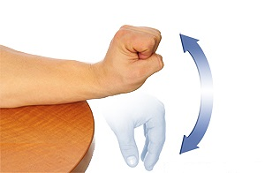  
Figure 3.1 Wrist extension and flexion [21]

The other main wrist movement is the deviation; it can be ulnar o radial depending on which side the hand moves (Figure 3.2). The exercise is carried out on a perpendicular axis in respect to the flexion/extension exercise. Again hand can be either opened or closed, palm down. The patient has to slowly bend the wrist as far as he/her can from side to side.

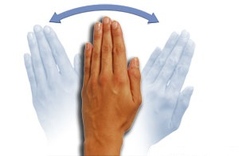  
Figure 3.2 Wrist radial and ulnar deviation [21]

### 3.3.2 Other exercises

For further information we describe a set of exercises for hand rehabilitation. The first exercise that we present is the tendon glide (Figure 3.3). Starting position: open hand, fingers and thumb pointing straight up, relaxed wrist following the line of fingers and thumb. The patient has to curl his/her fingers so that the top two joints in them are bent, and the fingers wrap down. The fingertips should touch or be near the base of the fingers. Next the patient has to make a fist by bending his/her knuckles. Then he/she has to unwind his/her fingers slightly so that the fingertips can touch the base of the palm. Finally he/she can move back to the starting position, with fingers and thumb pointing up.

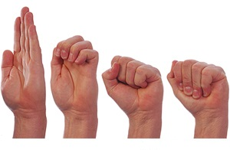  
Figure 3.3 Tendon glides [22]

Specific for the thumb are the flexion/extension (Figure 3.4) and abduction/adduction (Figure 3.5) exercises. The former exercise consists in bending the thumb downward and across the palm, so that the thumb touches the base of the little finger, and then straightening it.

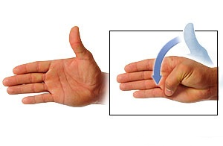  
Figure 3.4 Thumb flexion/extension [22]

The latter consists in pulling the thumb away from the palm as far as the patient can and then slowly move the thumb back to the starting position (open hand, fingers and thumb pointing straight up, thumb resting against the index).

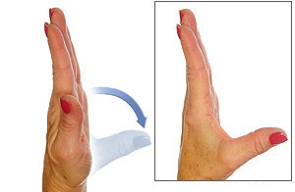  
Figure 3.5 Thumb abduction/adduction [22]

The finger opposition exercise (Figure 3.6), instead, is for all the fingers of the hand. Starting position: open hand, fingers and thumb pointing straight up, relaxed wrist following the line of the fingers and thumb. The patient has to touch his/her thumb to each finger, one finger at a time. The other fingers has to stay straight and pointing up as much as possible.

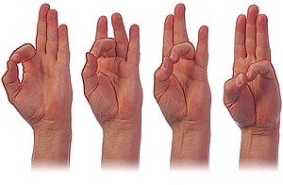  
**Figure 3.6 Finger opposition [22]**

Finger extension exercise (Figure 3.7) also involves all the fingers of the hand. Starting position: hand flat on a table, palm down. The patient lifts and then lower one finger at a time off the table.

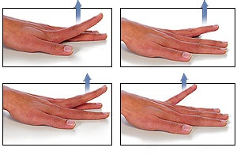

**Figure 3.7 Finger extension 1 [23]**

The last exercise is for finger extension too, and it is illustrated in Figure 3.8a. Starting position: fingers and thumb pointing straight up, palm down. The patient tries to pull each finger away from the adjacent ones as far as he/she can, then slowly returns to the starting position. A variant of the exercise consists in putting a small object between two fingers and have the patient trying to squeeze it (Figure 3.8b).

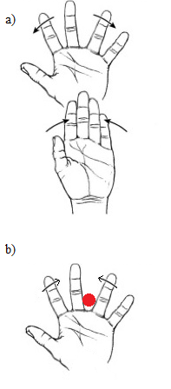  
**Figure 3.8 Finger extension 2 [24]**

# Chapter 4

Designing rehabilitation games for JIA

## 4.1 Designing rehabilitation games

Usually, when people think about games that has such a specific and important purpose as rehabilitation, they do not consider them as real games, but more as medical applications disguised as games. This impression leads people to underestimate these games’ potential and, more important, can result in a loss of interest from the patients in this non-standard therapy.

An important step forward, for serious games in general and rehabilitation games in particular, has been made by the introduction of new input interfaces, such as the Wii Remote and the Kinect. Using this new hardware, general public experienced new kind of games that did not focus only on pure entertainment. This benefited rehabilitation games in two ways: on one hand it drew the researchers’ attention to this different kind of therapy, on the other hand it made the line separating real games from serious games smaller. To erase that thin line, hardware alone is not enough, it is necessary to create a game with the idea that everyone can play it and enjoy doing it. Obviously, the main focus remains, in our case, on rehabilitation, but that approach allows us to create games that effectively draw the patient’s attention and, taking advantage of the typical addictiveness of videogames, help him/her to carry on with his/her therapy.

In order to achieve all of this, we need to apply those general game design rules that characterize every game, and add to those rules some specific ones for serious games in general and rehabilitation games in particular. It is on this set of rules that we focused in order to design our games.

The key point in game design is the entertainment. This aspect is fundamental, because the ability of a game to draw your attention and make you want to keep playing it is what differentiate the good games from the bad ones. The entertaining factor is even more important when dealing with rehabilitation games. As seen in Chapter 2, the main issue affecting patients who are going through a rehabilitation process is that of the lack of continuity due to the monotony of the exercises. Indeed, physical therapy consists of a set of repetitive exercises that, in the long term, may result as boring. Because of this, many patients tend to either to quit the physical therapy or to perform it irregularly, affecting the rehabilitation process and, consequently, their quality of life. Hence the need to create games that draw the patient’s attention, encouraging him/her to exercise as much as possible.

However, creating an entertaining game is not that simple. One of the main requirements is to balance the gameplay in order to make a game that is neither too easy, risking the patient to get bored, nor too difficult, hence frustrating: when the player either loses or performs bad, he/she has to feel like he/she was almost there, like if he/she plays once more he can perform better. In both cases, the banal game and the frustrating game, the patient may lose interest in the game and quit the therapy, and we don’t want that to happen.

Gameplay is not the only factor affecting the entertainment. Another important aspect is the feedback that the game gives to the player regarding his/her performance. A good way of designing such feedback is in terms of a rewarding system that encourages the player to perform better in order to increase the received reward.

Starting from these observations we designed are games trying to make them as much entertaining as possible. We opted for a really intuitive gameplay, that way the patient can quickly play the game without long training sessions. We also designed a balanced reward system that rewards a correct performance but, at the same time, does not penalize too much the possible errors. This reward system has been rendered by assigning a score to the player performance. This score is incremented every time the player does something good, but it is not decreased when he/she makes a mistake. In this way, a patient that has done something good and a lot of mistakes won’t see his efforts nullified by a zero points score, instead he/she will have a score comparable with those of his/her friends. The possibility itself to compare scores with the friends can, indeed, encourage the patient to put more effort in the exercises, hence influencing both the correctness of the performance and the longevity of the game.

As seen in Chapter 3, children affected by JIA are both male and female and the difference of age between them can be substantial. Since different people, in different maturation states, have different tastes and enjoy different things, we diversified our offer, designing different types of games. We tried to reach a range as wide as possible of patients and to do so we designed four different standalone games, with some common features that now we are going to discuss.

The first genre on which we focused was that of musical games or rhythm games. The success of games like Guitar Hero [27], and other similar ones, has proved how a variety of people enjoy playing this kind of games, regardless of sex, age or gaming background. Their ability to turn a passion of a lot of people into a game, transforming a simple mechanical gesture such as that of tapping to the rhythm while listening to the music into something enjoyable, is the core of this success. It is starting from these observations that we decided to create this kind of game. Moreover, having the chance to create hundreds of tracks, the game longevity increases dramatically (just think to all the expansions made for the Guitar Hero or Rock Band games).

The second type of game on which we focused was that of casual game. This kind of games are very intuitive and are aimed to reach people that does not have a strong gaming background. Their main features are a simple and intuitive gameplay, that doesn’t require too much effort, a clean graphic style and, usually, brief duration. We chose to design this kind of game because, as the spread of smartphones increases, almost everyone is stumbled upon this games. In particular, we designed a Flappy Bird-like [28] game. For the ones who do not know the original game, the aim of Flappy Bird is to make a bird jump across a series of tubes by tapping the screen with the finger. Even though from this description it could sound like an easy game, it is instead quite difficult, and the couple easy gameplay-difficult game makes it rather engaging. That is why we chose this specific game. Furthermore, being it a rather famous game, it could help the patient in perceiving the game as a real game, also played by his/her friends, and not a medical application.

The third game that we designed is an arcade game. It goes back to the old arcade games where you had to move the character from left to right in order to catch (or avoid) some objects that moved towards it. In our case, the player moves from left to right, and vice versa, a skier who is running down a track and has to pass through a series of flags. This game, too, has a very simple and intuitive gameplay, since the connection between the hand’s movement and the movement of the character on the screen is quite immediate. We chose this kind of arcade game in particular because it allows the patient to work well on the range and on the alternation of movement.

The fourth and last game has been designed to be more entertaining also for older children. It is a 3D flight simulator. Starting from the graphic, more complex than those of the other three games, to the environment where the game takes place, we tried to design a game that would attract people who wanted a more mature experience rather than that offered by the casual game or the arcade one. In the game, the patient pilots an airplane by moving the hands; the aim is to make the plane pass through a series of circles (something similar to Aironauts [29], for the ones who remember it, or the Quidditch sessions in the Harry Potter games [30]). The possibility to create different paths, developed an a potentially vast area, allows to live every time a different game experience, that could be adapted to the player’s level of challenge.

Providing four different games to play to is also useful for each patient in order to keep him/her motivated and engaged by varying the virtual environment, instead of performing the same exercise in the same game over and over.

As said before, for each game has been defined a rewarding system that increases the score when the player does something good, but does not decrease it when he/she makes a mistake (except for the Flappy Bird-like game, where, if you hit a tube, the game ends). Given that the main reason for choosing this solution is not frustrating the player, there are also specific reasons for each game. For the rhythm game, we took into account the intrinsic difficulty of the game and the fact that some people have poor sense of rhythm (not depending on their health status). If the patient hits correctly only a small percentage of notes and the game decrease his score for every missed note, he/she will feel like all his efforts were for nothing and will quit the game. Regarding the arcade game, maybe a patient can perform only slow movements, due to joint stiffness or pain, so it could happen that he could not be able to reach in time a couple of flags if they are too far from the previous couple; but this is not his/her fault, so it is unfair to penalize him/her. Same goes for the plane simulator. Maybe, when creating a path, an object could be set too far away for a patient to reach it with his/her limited range of motion. Also in this case, this is not the patient’s fault, so it is unfair to decrease his/her score.

The scoring system is not only a good feedback for the patient, but it is also a useful first qualitative feedback for the therapist about the patient’s performance. In fact, the therapist, knowing the number of obstacles in a game and the patient’s score can infer whether the patient performed well or not.

As you can see, except for the last two paragraphs, until now we just discussed about pure game design, without mentioning the rehabilitation features. That is because, in designing the games we wanted our will to create real games to show through. We did not want to make special games for special kids, but games for kids. Games that a kid would want to play either alone or with his friends.

Obviously, while designing the games we had to take into account also the rehabilitation side of the applications. To do so, we based on the game design rules find in the literature (Chapter 2). Four are the key point on which we focused: the ability of the game to adapt to the capabilities of the patient, the possibility for the therapists to create custom game levels, the need to save every information about how the patient performs during the exercises and the possibility to see again the exercise carried out by the patient.

Designing the movement management we had to take into account the different limitations of the patients. Keeping the main objective to create games that could be played by everyone, we designed a movement system that allows everyone to play and have good results regardless of his ranges of motion. In some games, like the plain simulator one, it has been obtained by adapting the difficulty of the track to the player’s range of motion. In others, like the arcade game, we adapted the character’s movement to the player’s limitations, allowing everyone to reach the extremes of the track regardless of the range of motion.

Regarding the level design, we tried to make the movements to be performed the more uniform as possible. We designed two ways of creating the levels: a random one and a custom one. The custom creation gives the therapist the freedom to create a path that resembles the specific movement that he/she wants the player to perform. The therapist has to simply do the exercise once and the system will track and save his/her movements and create the associated path. Using the custom creation, the therapist can create both more generic paths and paths specific for a certain patient or group of patients. The random creation, instead, is automated. The therapists sets some parameters, like the duration of the exercise or the range of motion (expressed in terms of difficulty), and the system creates a random uniform path. Using the level creation modules, the therapist can statically adapt the difficulty of the game to the patients’ ability, keeping them motivated to play to the games.

One of the benefits of using rehabilitation games for physical therapy is that they allow the therapist to retrieve data in order to analyze the patient’s performance. Thanks to these data, indeed, it is possible both to keep track of the patient’s progress and to have a both a quantitative and qualitative feedback about his/her movement capabilities. For this reason we chose to save two kinds of information: the patient’s range of motion and every position of the hands during the game. The first information is useful to see if the therapy is helping the patient in reducing his/her movement limitations over time, while the second is useful for the therapist to analyze the patient’s movements in order to decide on which kind of movement they have to work more.

The data saved during the exercise has also been used in the designing of a replay mode that would allow the therapists to see how the patient performed the exercise. This feature is useful both because it gives the chance to the therapist to see exercises performed at home by the patient, so without the therapist being there, and also because it provides a qualitative feedback more immediate than the plots, that could be watched and analyzed over and over again. It helps the therapist to promptly find possible mistakes in he exercises and to directly show them to the patient in order to let him understand what he did wrong.

The last two features (saved data and replay mode) are crucial for the therapists because they help them to verify the effectiveness of the treatment, to keep track of the patient’s progress and to define possible improvements to the therapy.

## 4.2 Preliminary meeting and requirements

During the first meeting, the therapists introduced us to how the physical therapy for JIA works. After a brief explanation of how the inflammation affects the functionality of the joints and which are the main goals of physical therapy (see Section 3.3), the therapists showed us a set of exercises with the help of a couple of patients. They showed us exercises for both the upper and lower limbs, involving large joints such as the knee and the hip joint, and small joints, e.g. the ones of the wrists and the fingers.

We divided the set of exercises in two groups: those for the upper limbs and those for the lower limbs. We decided to focus on the upper limbs - on the hands in particular - and we searched for suitable input devices that would allow us to easily recreate in a virtual environment the movements required by the exercises.

The device that drew our attention is the *Leap Motion Controller* (LMC) [25] (Figure 4.1). LMC is a small device (height 1,27 cm, width 3 cm, depth 8 cm) that connects to a PC via USB cable. The Leap Motion system recognizes and tracks hands, fingers and finger-like tools. The device operates in an intimate proximity with high precision (0.01mm) and tracking frame rate and reports discrete positions, gestures, and motion.

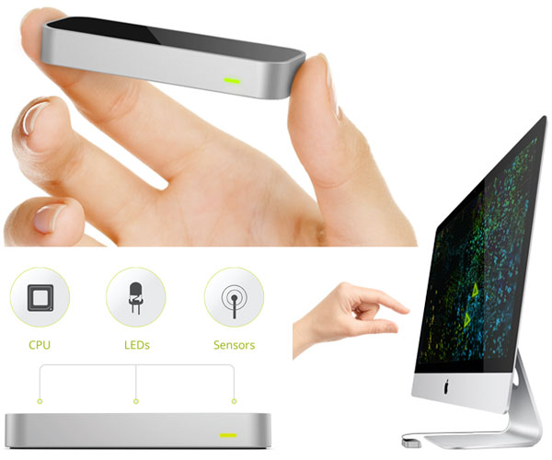  
**Figure 4.1 Leap Motion Controller**

The Leap Motion controller uses optical sensors and infrared light. The sensors are directed along the y-axis – upward when the controller is in its standard operating position (facing upward) – and have a field of view of about 150 degrees (Figure 4.2). The effective range of the Leap Motion Controller extends from approximately 25 to 600 millimeters above the device [26]. The Leap Motion software combines its sensor data with an internal model of the human hand to help cope with challenging tracking conditions.

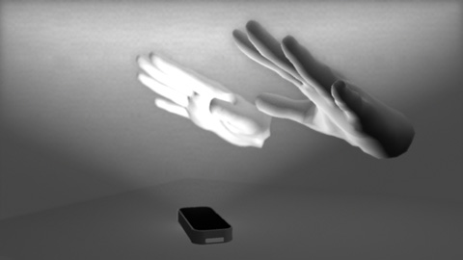  
**Figure 4.2 LMC’s view of the hands**

Figure 4.3 shows how LMC sees the hands. It can track both left and right hands and forearms at the same time; for each hand it can track every finger and the relative phalanges. Actually a real thumb has one less bone than the other fingers, but, for programming reasons, the Leap Motion thumb model includes a zero-length metacarpal bone so that the thumb has the same number of bones at the same indexes as the other fingers. Using the API we can retrieve the position and rotation of the forearm, the palm, and each bone in the fingers, according to the coordinate system in Figure 4.4.

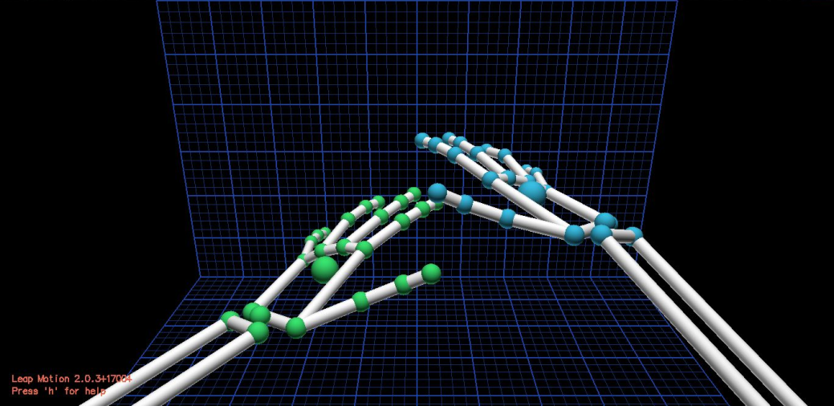  
**Figure 4.3 Leap Motion Diagnostic Visualizer**

The Leap Motion system employs a right-handed Cartesian coordinate system. The origin is centered at the top of the Leap Motion Controller. The x- and z-axes lie in the horizontal plane, with the x-axis running parallel to the long edge of the device. The y-axis is vertical, with positive values increasing upwards (in contrast to the downward orientation of most computer graphics coordinate systems). The z-axis has positive values increasing toward the user [26].

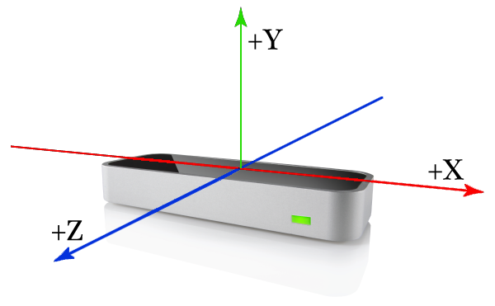  
**Figure 4.4 LMC right-handed coordinate system**

The Leap Motion software also recognizes certain movement patterns as gestures which could indicate a user intent or command. The movement patterns recognized by the Leap Motion software are: the circle gesture (a finger tracing a circle, Figure 4.5a), the swipe gesture (a long, linear movement of a hand and its fingers, Figure 4.5b), the key tap gesture (a tapping movement by a finger as if tapping a keyboard key, Figure 4.5c), the screen tap gesture (a tapping movement by the finger as if tapping a vertical computer screen, Figure 4.5d).

In the end, we decided to use the LMC as input device for five main reasons:

* the player does not have to hold any physical device with his hands, so he can move freely and perform better exercises;
* the precision of the device allows us to perform a better tracking of the hand movements;
* the device have a high portability, given its small dimensions, so the patient can do his/her exercises wherever he/she wants (presuming that he/she has access to a PC);
* it is easy to install and intuitive to use, so there is no need for expert support;
* it is relatively cheap (89.99€), so almost everyone can afford it.

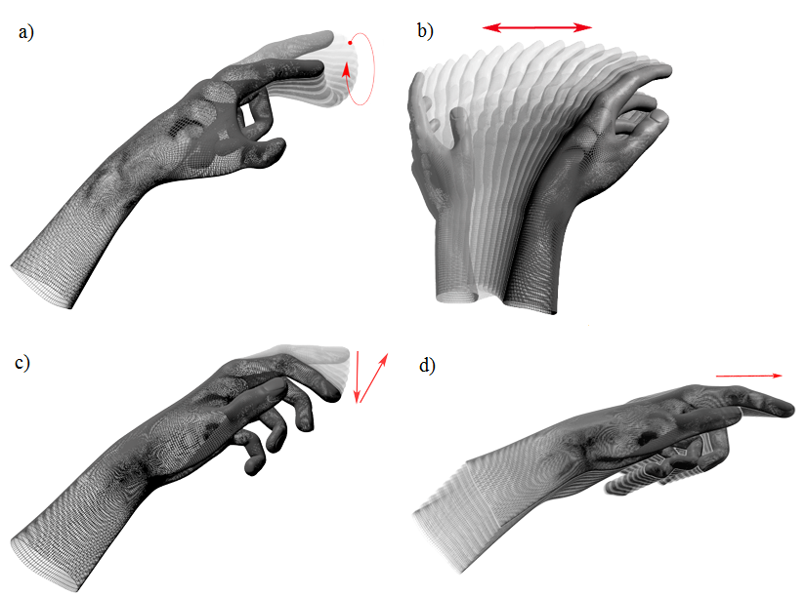  
**Figure 4.5 Gestures recognized by the LMC**

After some testing with the device, we proposed to the therapists a set of games. For the reasons discussed in the previous section, we designed four different types of games, trying to make them appealing for a wide range of people.

We also asked the therapists which features would have been useful for their work, in order to implement them in the games. What came out was similar to the set of features defined in literature (Chapter 2) and to the rules of game design upon which we based our games (Section 4.1). The first thing that the therapists mentioned was the possibility to have a quantitative feedback from the games, i.e. collect data of the patient’s movements. The main interest of the therapists was to have information about the wrist’s extension, flexion and deviation degrees throughout the game.

A qualitative feedback was required as well, in terms of being able of examine how the patient does an exercise. This feature came out as a consequence of the possibility for the patient to perform the exercises at home, without the therapists’ supervision. Hence, a way of displaying the patient’s hand movements during the exercise was necessary in order to assess its correctness.

## 4.3 Main application and games

In this section we present the final versions of the games, developed following the results of our iterative design approach. This design methodology is based on a cyclic process of prototyping, testing, analyzing and refining of the product. We validated our designs with the results of the experimental sessions, both in terms of qualitative feedbacks (from therapists and subjects) and quantitative feedbacks (the data retrieved during these sessions). Thanks to the iterative design we were able to gradually improve our games, developing the final versions presented in this section.

We developed four different games. Right now they are all part of a single application, but they can be easily divided and can work as standalone. Figure 4.6 illustrates the architecture of the system. The LMC is the physical interface between the user and the PC. It tracks the user’s hand movements and sends them as input to the application.

The application is divided in two parts, one for the therapist and one for the player. In his/her section, the therapist can create custom levels for each game. In this way he/she can create exercises specific for each patient. The therapist can create the levels either manually or randomly. In the first case he has to perform the exercise that will be recorded and stored. In the second case he can simply edit some parameters and then the application will automatically generate a random level.

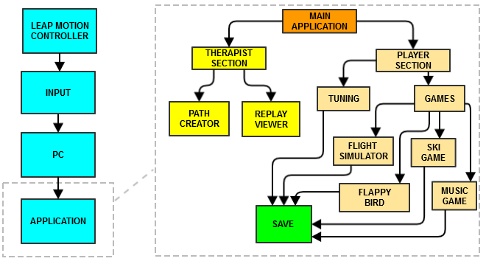  
**Figure 4.6 System architecture**

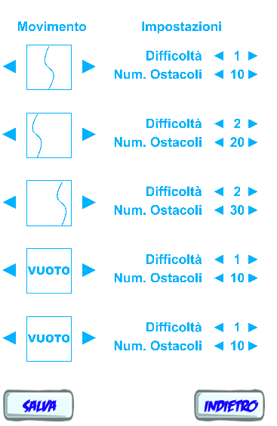  
**Figure 4.7 Random path generator**

Figure 4.7 shows one of the games’ random path editor. The therapist can define the number of obstacles in the game (influencing the duration of the exercise) and the difficulty of the exercise (i.e. the range of the movement to perform in respect to the maximum range of motion of the patient). In the case of Figure 4.7 the therapist can also decide to focus more on one side of the movement or the other.

In its dedicated section, the therapist can also see the replays of the exercises performed by the patients. Figure 4.7 shows an example of what the therapist can see in the replay mode. In the background plays the replay of match, while in a corner are shown the hands movements throughout the game.

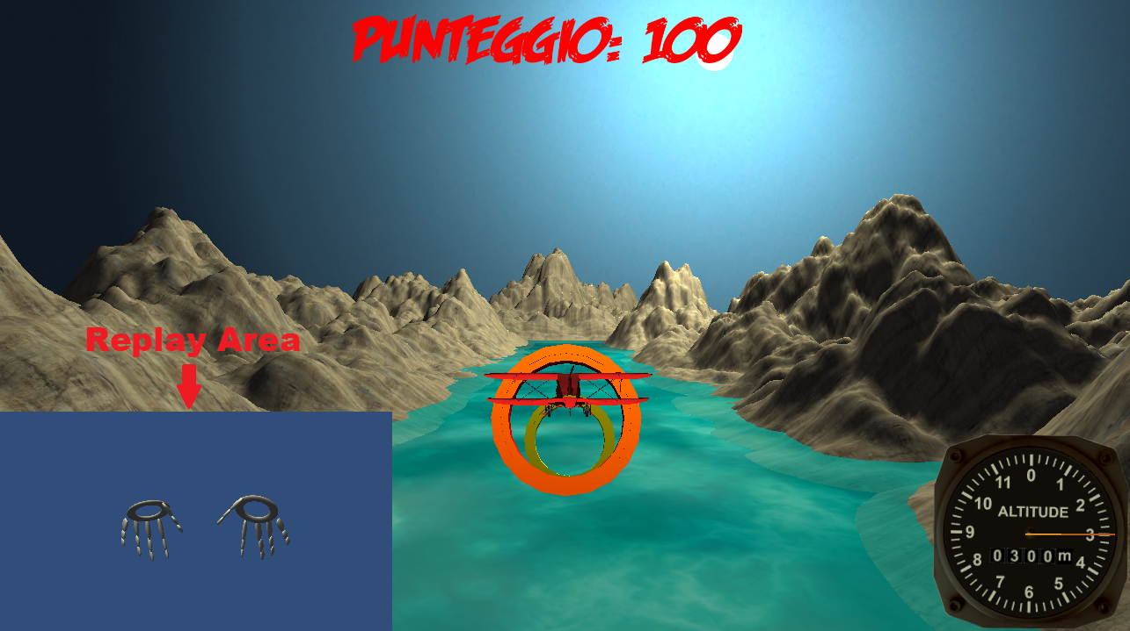  
**Figure 4.8 Replay mode**

The player’s section of the game is divided in two phases. If the player is playing for the first time or if too much time has passed from the last tuning session, he/she has to go through a tuning session.

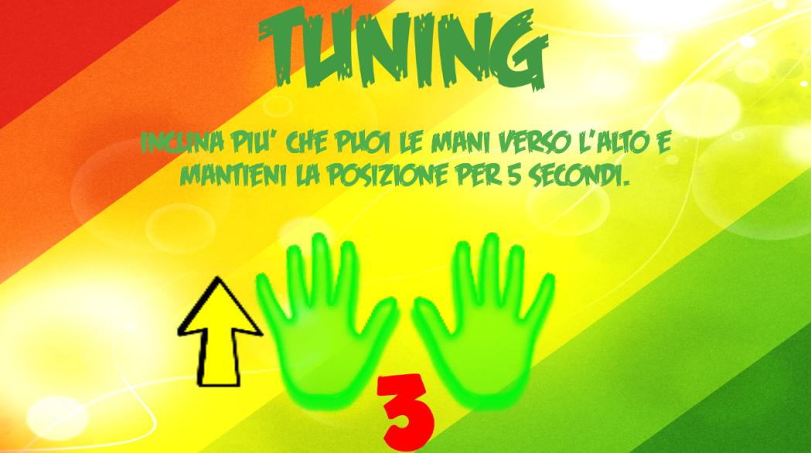  
**Figure 4.9 Tuning session (translation : ”Bend upwards your wrists as much as you can and keep that position for five seconds”)**

The aim of this session is to store information about the patient’s range of motion. We ask the patient to reach the maximum of his range of motion in flexion, extension, radial and ulnar deviation (Figure 4.8) and we save those values. This information is useful both for the therapist, because he/she can analyze the patient’s level and his/her progress, and for the application, in fact it is used to adapt the game to the patient’s capabilities, so he/she does not get frustrated.

After the ranges of motion are stores, the player can play the available games. Each player has his/her own profile where all his/her information is stored (name, ranges of motion, last time that he/she performed the tuning session, highscores). During the exercises all the hands movements are saved to a file. This data is used in the replay mode to recreate the player’s performance, but can also be analyzed (as we do in Chapter 5).

As for the games, given the different ages and interests of the patients we developed a variety of games that we believe could be appealing to a wide range of players. One of the available games is a rhythm game, like Guitar Hero. The reasons for this choice are quite simple: tapping something to the rhythm of the music is quite mechanical (even if not always simple), everybody loves music and Guitar Hero and the other similar rhythm games proved that this genre is appealing for a different kinds of people. The second game is a casual game. We developed a flappy bird-like game, because it is intuitive and quite famous, so it gives the patient the idea that he/she is playing a real game, like the ones that everyone else play. The third is an arcade game. The player controls a skier that has to pass through a series of flags as in a slalom. It is similar to those old portable games where you had to avoid objects coming at your character by moving it to the left and to the right. Finally, with the fourth game we tried to make something a bit more mature for children a little bit older. It is a 3D flight simulator game. In this game the player drives a plane moving his hands and has to pass through a series of circles.

In the next sections we briefly describe each games, showing some screenshots for a better understanding.

### 4.2.1 Rhythm game

The aim of this game is to help patients doing wrist flexion exercises. While music plays in the background, buttons fall from above and the player has to push them at the right time. Figure 4.10 shows the interface of the game. There are two lines, one for each hand. The buttons come down on each line and the player has to press them with the correct hand while they are in the relative circle. The pressing is achieved by the flexion motion, keeping the forearm still, horizontal, and quickly bending down the wrist, as if the player is trying to push a physical button like the ones in quiz shows.

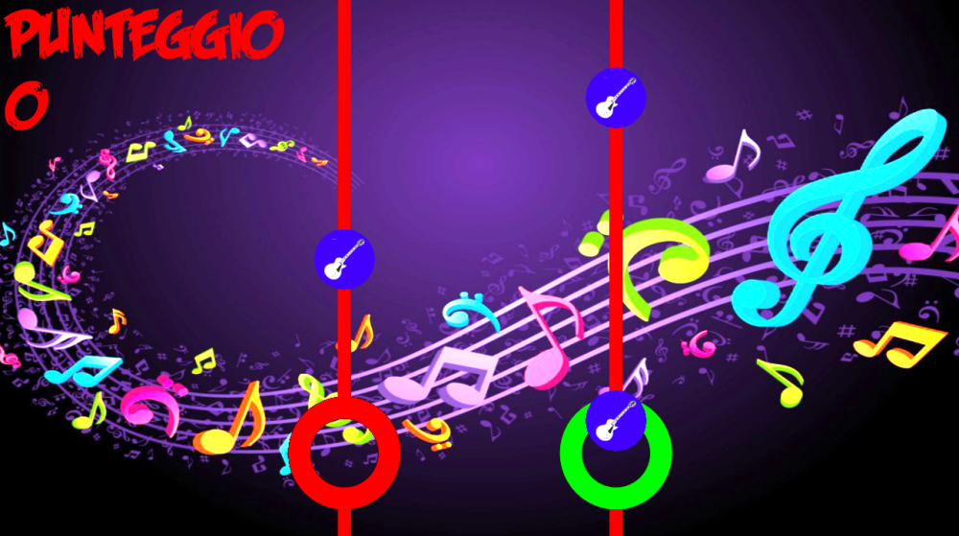  
**Figure 4.10 Rhythm game**

A certain amount of points is given to the player for each button pressed correctly. No points are assigned either for not pressing a button or for pressing when there is no button in the circle. We adopted this scoring method instead of penalizing the player for bad timing, because, given the effects of the disease on the motion, it is not easy for the patient to have perfect timing (even some healthy people are bad at timing games) so it could be frustrating to lose all the points earned, and we don’t want the player to be frustrated and quit exercising.

Right now the button positions are defined by the developer. Future implementations will include the possibility for the therapist to create a custom button track for each song.

### 4.2.2 Flappy Bird-like game

This game involves both wrist flexion and extension. The player has to make the character pass through a series of tubes (Figure 4.11) until the end of the track. The game is played with one hand at a time. We implemented two ways of moving the character, one involving only the extension movement, the other involving both extension and flexion movements. The first game mode is similar to the original Flappy Bird game. In the original game, the player has to tap on the screen in order to make the character jump at the correct height to pass through the pipes. This action is recreated in our game using a movement similar to the one used in the rhythm game to press the buttons, but in the opposite direction. The player has to quickly bend up the wrist to make the character jump, as if he/she was trying to create a gust of wind beneath the character.

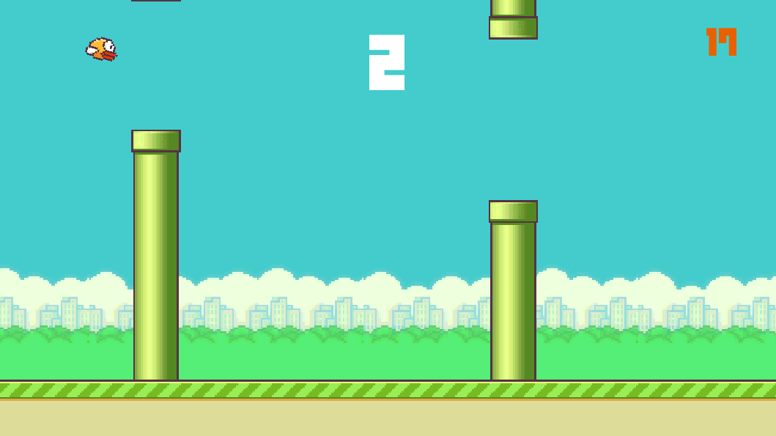 **Figure 4.11 Flappy Bird-like game**

In the second game mode the player can directly control the character’s height using his wrist motion. Keeping the hand parallel to the ground will make the character stand in the center of the screen. Bending up the wrist will make the character go up, while bending the wrist down will make it go down. The height reached by the character depends on the motion degree of the wrist. The closer the wrist gets to one of the extremes of its range of motion, the higher or lower the character flies.

If the character touches one of the pipes before reaching the end of the track, the game stops. The score is simply the number of pipes that the character has gone through.

With respect to the original game, we increased the distance between the couples of pipes, in order to give the patient enough time to perform the correct motion.

### 4.2.3 Ski game

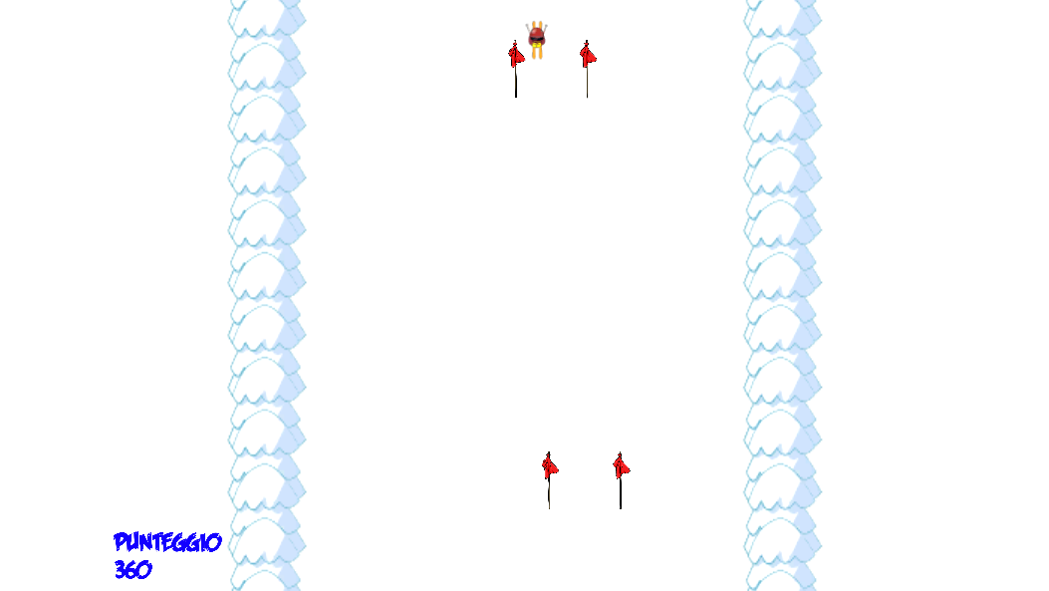  
**Figure 4.12 Ski game**

This game involves both wrist extension/flexion and radial/ulnar deviation, although not in the same exercise. The setting is quite simple (Figure 4.12): a skier descending through a track. While descending he will encounter couples of flags through which he has to pass. The player can move the character right and left using one hand. He/she can do this in two ways, depending on the mode selected: by radial and ulnar deviation, with the palm facing down, or by wrist extension and flexion, rotating the hand by 90° and making a movement like a slap. As for the Flappy Bird-like game, the wider the movement, the further the characters moves on the screen. The relative position of the character with respect to the borders of the track is linked to the relative angle of the wrist with respect to the ranges of movements saved in the tuning session; in this way the player can reach both the borders of the track, avoiding the frustration of missing the further flags due to the limited range of motion.

For each couples of flags that the player has passed through a certain amount of points is added to the score. No points are subtracted for not passing through a couple of flags. The game ends when the player reaches the end of the track. In the case of a custom made track, the score can be also an indirect feedback for the therapist regarding the patient’s performance.

As anticipated, the track can be either random generated or created by the therapist. The random generation takes some parameters from the therapist, e.g. number of flags, distance between the flags, and then creates automatically the track. Custom generation requires the therapist to perform the exercise that he/she wants to be replicated. While performing the exercise, the application will track the excursions of the therapist’s wrist and place the flags accordingly.

The game included another mode, where the player had to avoid the trees placed on the track. In order to do that, the player had to perform a quick movement either to the left or to the right with the hand. We decided to remove this mode because it was too difficult (Section 5.3).

### 4.2.4 Plane simulator

The last game is a plane simulator. It involves both wrist flexion/extension and radial/ulnar deviation in the same exercise. It can be played with both hands as well as with one hand. The hands can be both opened or closed to a fist.

The game is quite simple: the player has to pilot a plane through a series of rings. For doing this he has to move one hand or both hands as if they were the plane itself. Bending up the wrist will tilt the plane upwards while bending the wrist down will result in the plane tilting downwards and following that direction. Same goes for bending the wrist to the left and to the right.

During the testing sessions we observed that children tend to immerse in the game, forgetting to control their hands positions, so we added some visual help for both the two hand mode and the single hand mode.

In the two hands mode the main problem was that the children were often overlapping their hand, resulting in bad tracking for the Leap Motion Controller (LMC). We added two placeholders (the yellow hand shapes in Figure 4.13) for the hands that indicate the optimal distance between the hands. Two hands overlays (the green hand shapes in Figure 4.13) move accordingly to the player’s hands and show the real distance between them. If the hands are not too close or too far apart, the overlays are coloured green; otherwise they become red and a warning message appears on the screen. The arrow in Figure 4.13 shows to the player in which direction he/she has to move the plane in order to pass through the next obstacle.

In the single hand mode we observed that children were not aware of the LMC position while playing, so we added a LMC placeholder on the screen and a hand overlay that shows the player the position of his/her hand relative to the LMC (Figure 4.14).

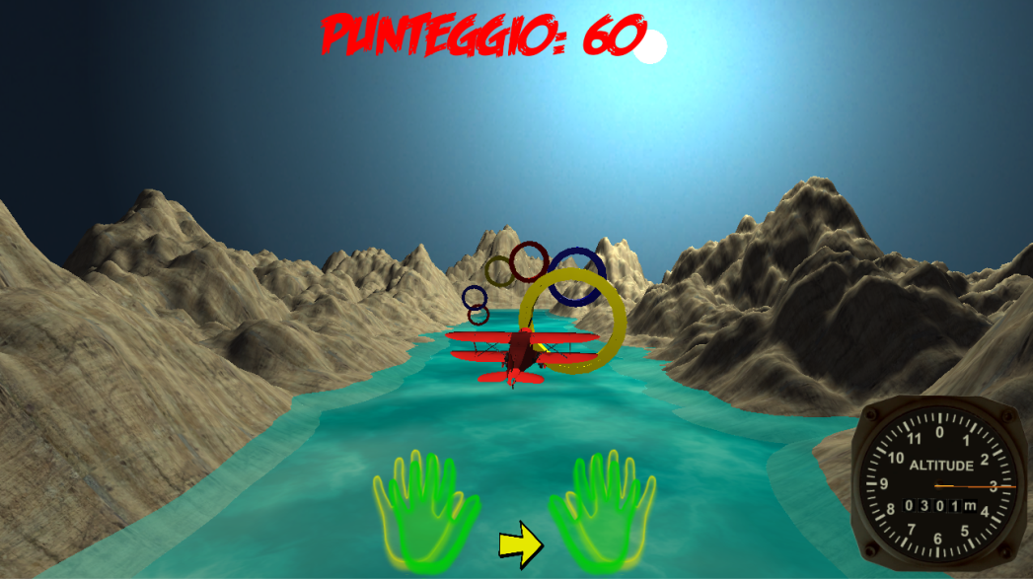  
**Figure 4.13 Plane simulator – two hands**

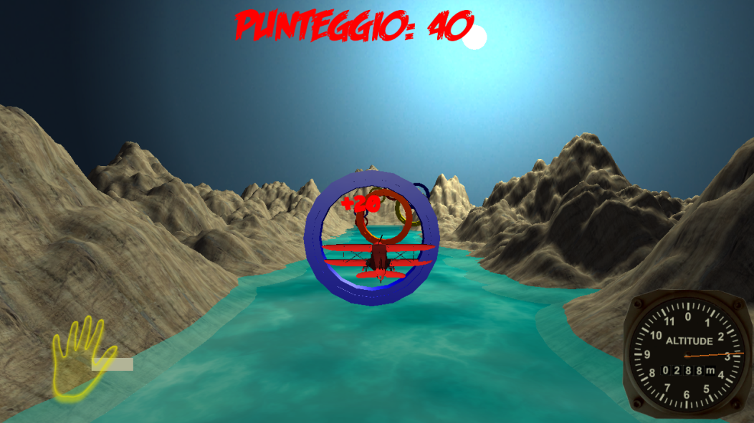  
**Figure 4.14 Plane simulator – one hand**

The tracks are created by the therapist, in a similar way as the ski game. The therapist performs the exercise and the application tracks his/her movements and places the rings. Before creating the track, the therapist can customize some parameters such as the plane speed or the time interval between the placement of a ring and the next one. In this way the therapist can influence the speed of the exercise making it more or less difficult. Future implementations will include also a random track generation.

The scoring system is similar to the one implemented in the ski game. Each time the plane passes through a ring, the score is increased by a certain amount. Avoiding a ring does not decrease the score. The game ends when the player reaches the last ring.

# Chapter 5

Testing and data analysis

In this chapter we present the set of experiments that we performed to validate the games on human subjects.

We performed three experimental sessions involving human subjects. The first two sessions were mainly used to tune the development of the games base on the subjects and therapists feedbacks. In the following sessions we focused more on collecting data in order to evaluate how the subjects used our games.

## 5.1 Experimental setup

Each experimental session took place at the Clinica Pediatrica G. e D. De Marchi. Each session was run on a notebook HP Pavilion dv6 with a 15.6” screen, Intel® Core™ i5-2410M CPU @2.30GHz, 4GB DDR3 SDRAM, Intel Sandy Bridge-MB GT2 video card, Windows 7 Home Premium 64 bit OS. The notebook was placed either on a desk or on a medical bed, based on the therapists’ choice. The *Leap Motion Controller* (LMC) was placed between the notebook and the subject, on the same surface of the notebook, facing upward, about 12 cm away from the notebook.

In front of the notebook was placed a chair with a seat that would let the subjects extend their arms with the hands above the LMC, keeping a hand-LMC distance of at least 10 cm.

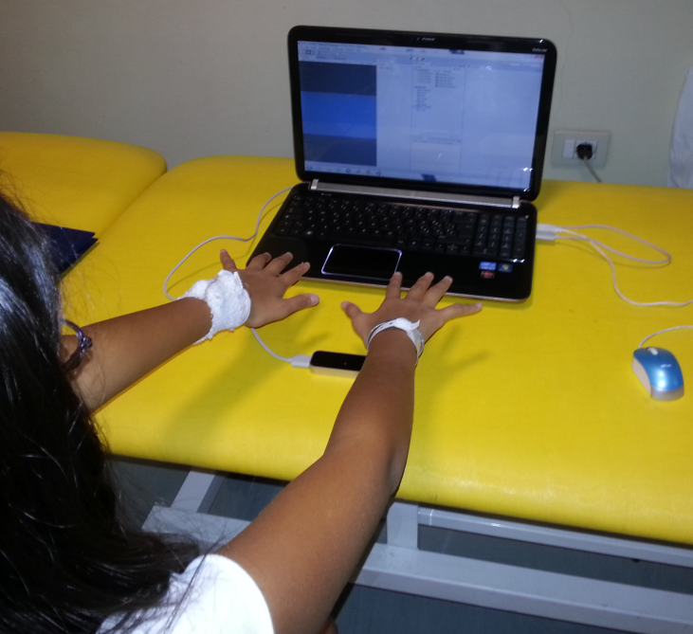  
**Figure 5.1 Experimental setup without the bolster**

We tested four different configurations for the positioning of the arms. One had the subjects keeping their arms above the leap without any support (Figure 5.1).

## C:\Users\Rocco\Dropbox\Angela-Rocco\20140911_121736.jpg Figure 5.2 Experimental setup with the bolster

The second configuration added a bolster under the forearm, as a support (Figure 5.2). The aim of these two settings is to have the subjects keeping their forearms as straight as possible, moving only the wrists in order to play. Furthermore, the second configuration helps reducing the effort of the subjects’ shoulders. We opted for this setup because the bolster is frequently used in physical therapy, hence it is easy to find one in a dedicated ward.

The third configuration (Figure 5.3) added a couple resting orthoses - generally used for the fixation of the foot and ankle – on the bolster. Aim of the orthoses was to avoid the compensatory movement of the forearms performed by the subjects instead of bending the wrists. The choice of using the orthoses came from the therapists, since they generally use these supports in the clinic.

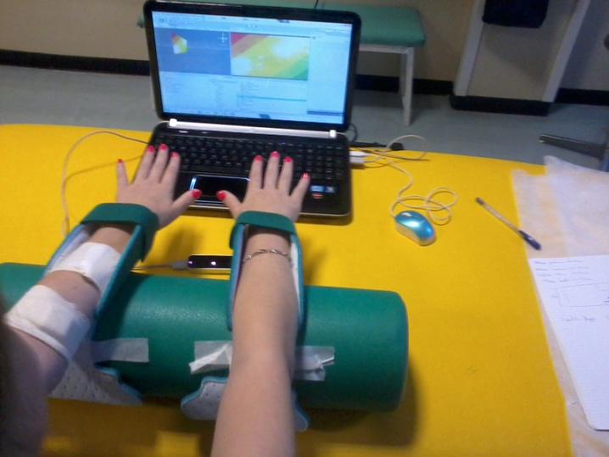  
**Figure 5.3 Experimental setup with the bolster and the orthoses**

Finally, in the fourth configuration (Figure 5.4) we substituted the bolster with a higher wedge. We made this change because we noticed that using the bolster the subject’s hand went too close to the LMC while performing the flexion movement. Also the therapists proposed to change the support, because they noticed the subject’s tendency to tilt her forearms back and forth, hence the need of a wider surface to lay the arms.

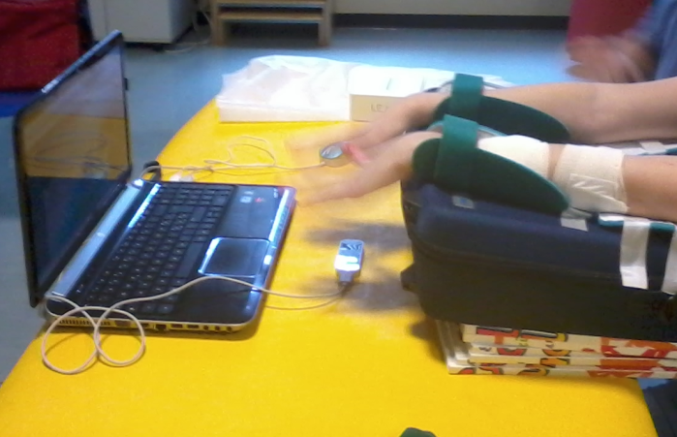  
**Figure 5.4 Experimental setup with the wedge and the orthoses**

## 5.2 First experimental session

Three subjects – all females – took part to the first experimental session. We will refer to the subjects as S1, S2, and S3. S1 was ten years old, S2 was fifteen years old and S3 was twenty-one years old. S2 and S3 had articular issues affecting their hands and wrists, while S1 had limitations to the ankle movements.

The aim of the first experimental session was to obtain a first feedback that would validate our design, both from a medical point of view and with respect to the subjects’ entertainment. In order to reach this goal, we had the subjects perform several tests, for an overall duration of the session of about two hours. With S2 and S3 we focused on the hand exercises, while thanks to S1 we tested if the games could be played also using the feet.

In this set of experiments we tested two of the four games: the flight simulator and the Flappy Bird-like one. The flight simulator, in particular, was tested both with the hands and with the feet.

The tests were performed using the experimental setup defined in Section 5.1. In this session we used the version 1.2 of the Leap Motion SDK. We placed the notebook and the LMC on a desk, while the subjects sat on an adjustable stool.

The initial tests were performed without any support for the hands. The therapists noticed some fatigue in the subjects and we decided to put a bolster between their forearms and the desk, so they could lay their arms on it.

We asked the therapist to create a custom level for the flight simulator game, so she could simulate an exercise performed in a typical training session. Moreover, by doing this, we were able to show to the subjects how the game works and which movements they had to perform in order to complete the exercise. For the Flappy Bird-like game, instead, we used the random generator, creating a different level for each test.

### 5.2.1 Tested game modes

All the tests were conducted with the subjects only using their right hand. The therapists decided that they wanted to test only the one hand mode of the flight simulator game since they considered the two hands mode to be too difficult and wearing. The Flappy Bird-like game was tested both in the original mode and in the continuous movement mode.

### 5.2.2 Users’ feedback

The feedback from the subjects was quite good; they all enjoyed the games and, in particular, the scoring system added a challenge factor among the subjects that led them to focus even more on each exercise.

The subjects also gave us some feedbacks regarding the look and feel of the games, suggesting some additions and changes that would have made the games more appealing. In particular, for the flight simulator, they asked us to add some background music in order to make it more lively, and to modify the positions and textures of some game objects in order to have a better view and understanding of what is going on in the game.

The therapists’ feedbacks were also good. They noticed that the subjects enjoyed the exercises much more and it did not look like they were doing exercises. The subjects were doing without complaint the same exercises that they found to be boring and difficult during standard physical therapy. The level of focus required by the game, the victory goal and the level of entertainment created by the game itself and by the presence of the other subjects, exceeded the fatigue induced by performing the exercise. This may have been the most important feedback in order to evaluate the usefulness of our games and it allowed us to evaluate the goodness of our design choices.

An issue that we noticed while observing the tests of the flight simulator, was that the subjects tended to focus too much on the game and did not check their hand position relative to the LMC position, risking to go out of the LMC’s field of view. This issue has been resolved at a later stage by adding to the in-game graphic an overlay of the hand that shows its position with respect to the LMC (Section 4.2.4).

As mentioned before, we also made some tests using the feet instead of the hands. We wanted to verify if it was possible to trick the LMC into thinking that the subject was using her hand instead of her foot. If that was possible, the therapists could have used the games also for ankle rehabilitation. Sadly, the experiment did not go well. Being the LMC optimized for hand tracking, it had some issues recognizing the foot as a hand, making the flight simulator game unplayable.

**Figure 5.5 Performance of S2 playing to the flight simulator game**

### 5.2.3 Data analysis

In this section we present the data that we retrieved during the experimental session. We focus only on the exercises performed with the hands, since the system proved to be not suitable for playing with the feet.

Figure 5.5 shows the data collected from S2 playing to the game using her right hand, without using the bolster as a support.

The positive values in the extension/flexion plots represent the extension of the wrist, while the negative values are associated to the flexion. In the radial/ulnar deviation plot, instead, positive values are associated to ulnar deviation, while the negative ones are associated to the radial deviation.

The first thing that we notice, looking at the plot, is that the deviation movement is imbalanced. Comparing with the performance of S3 playing the same game (Figure 5.6), we note that they have the same trend, but the deviation plot in Figure 5.6 is centered in the origin. This means that the offset in the plot of Figure 5.5 does not depend on the level generated by the therapist but is likely due to the position of the end at the beginning of the game. In fact, the plane simulator game has a preliminary phase where the application asks to the patient to keep his hand straight on the LMC for a small amount of time, in order to save the information about the wrist’s angles at rest. This information is later used to adapt the movement of the plane to the movement of the hand. Hence, it is likely that S2 started the game with a radial deviation of almost 20°, setting the zero at that offset.

From a qualitative point of view we can see how the flexion and extension ranges in Figure 5.5 are quite balance, even though the extension has peaks a little bit higher than the flexion. We can also see from both the plots in Figure 5.5 how the therapist made a uniform level, that made the patient exercise both extension and flexion, and radial deviation and ulnar deviation.

As we can see, the plots are noisy; this depends on two factors: the LMC and the bolster. The LMC’s tracking is a generally noisy, it could be seen quite immediately using the Leap Visualizer how the virtual counterparts of the hand shake a bit while tracking. Not using the bolster as a support also influenced the performance, since it was wearing for S2 to keep her arms lifted. The effect of the bolster on the performance can be seen by comparing the plots in Figure 5.6 and 5.7. Both figures illustrate the performance of S3 playing the flight simulator game with her right hand. But the test in Figure 5.6 was performed without the bolster, while in the test illustrated in Figure 5.7 S3 was able to lay her forearm on it. We can see that while the plots in the two figures have the same trends, those in Figure 5.7 are crispier than those in Figure 5.8. This proved how useful can be having a support where the subjects can lay their forearm while doing the exercise. Reducing the fatigue, the patient can indeed perform a cleaner exercise.

**Figure 5.6 Performance of S3 playing to the flight simulator game without the bolster**

In the radial/ulnar deviation plot of Figure 5.6 we notice a peak that exceeds 80°. This is due to a disturbance that went in the field of view of the LMC, temporarily affecting its tracking. Especially using the version 1.2 of the Leap SDK, we noticed these strange behaviors when an external object or part of a body entered the LMC’s field of view while someone was playing. Hence, the need for the therapists and the other who participate to the therapy, to leave a bit of space between them and the patient who is doing the exercise. It is important also to clear the LMC’s flied of view from external objects that could interfere with the tracking.

As said before, analyzing the plots in Figure 5.5, 5.6 and 5.7 we note how the therapist created a uniform exercise that stimulates the wrist joint in all the four main directions. Especially with respect to the extension/flexion movement S3 gradually alternated flexion and extension, keeping the range under ±40°. The deviation side of the exercise was less balanced. As we see, in the first part ulnar and radial deviation alternate, but radial deviations are wider than the ulnar ones. In the end there is only an increasing ulnar deviation. This remarks the need for a random generator that creates levels more uniform as possible.

Figure 5.8 illustrates the performance of S2 playing to the original mode of the Flappy Bird-like game. She played the game with her right hand, resting her forearm on the bolster. We note that she made a lot of sharp movements in the first five seconds, but as she get used to the game, the peaks get more distant.

Anyway, this game mode requires an impulsive movement rather than a uniform one. This could be a problem, because could cause pain in some patients or can stress too much the joint. If we look again at the peaks in the beginning of the plot in Figure 5.8 we can see how S2 performs six sharp extensions in about five seconds. Luckily she did not complain about pain, but the joint was too much stressed.

Figure 5.9 shows the performance of S3 playing to the original mode of the Flappy Bird-like game. She played with her right hand and used the bolster to rest her forearm.

**Figure 5.7 Performance of S3 playing to the flight simulator game with the bolster**

We can see how S3 had a more relaxed approach. Even though the plot still presents some sharp peaks, as the one of Figure 5.8, they are more distant from one to the other. Also in this case the exercise is not uniform. There is no gradual movement and we can see how hard it is for the subject to reach more than 20° in extension with a single impulse movement.

These evaluations led us to not consider this game mode as a good exercise. Anyway we decided to keep it with the other games, since the subjects had fun playing to it.

Figure 5.10 and 5.11 illustrate the performances of S2 and S3, respectively, while playing the continuous movement mode of the FlappyBird-like game. The first thing that we notice, looking at the plots, is that the movement is not balanced between flexion and extension. In five plots out of six, the extension movement is required more than the flexion movement. It depends on the game random generator, which created levels with targets not evenly distributed.

**Figure 5.8 Performance of S2 playing to the original mode of the Flappy Bird-like game**

**Figure 5.9 Performance of S3 playing to the original mode of the Flappy Bird-like game**

Analyzing the plots in Figure 5.10 we can see how the overall movements of S2 change gradually, especially in the third test, since she understood how to move properly the character and had more training. Also the sequence of plots in Figure 5.11 shows how S3 gradually got acquainted with the game and performed better after some practice. In particular we can see how in the first test she lose almost immediately. In the second test she lasted longer, but still she had some problem stabilizing the movement, see for example the peaks between fifteen and twenty seconds that slowly decrease in intensity. In the last test, probably due also to an easier level created by the random generator, she performed a quite uniform exercise, with gradual movements, though the angles where not so wide.

**Figure 5.10 Performances of S2 playing the continuous movement mode of the Flappy Bird-like game**

**Figure 5.11 Performances of S3 playing the continuous movement mode of the Flappy Bird-like game**

### 5.2.4 Final remarks

This first experimental session helped us to validate our design choices. We could see how the subjects were effectively entertained by the games. We have seen, in particular, how playing these games in group can increase the fun, encouraging the patients to exercise. Also the positive feedback of the therapists helped us to evaluate the goodness of what we designed, confirming the usefulness of these games.

The session also gave us some useful indications about how to change and improve our games. The two hands mode in the flight simulator and the original mode in the Flappy Bird-like game are not suited for all the patients. The two hands mode is too difficult for someone and require more concentration than the one hand mode. While, the original Flappy Bird mode requires too sharp movements that not everybody is capable of doing. Furthermore, the original mode make the patients perform a less uniform movement than the one performed in the continuous mode. We decided to leave those two modes in the relative game, anyway, if some patients want to try a different gameplay experience.

The feedbacks about the visual aspects were useful as well, helping us improving the gaming experience and making the games more appealing for the users.

## 5.3 Second experimental session

Two subjects, S1 and S2, took part to the second experimental session. They were both female: S1 were twenty years old, while S2 was the same S2 that participated to the first experimental session. Both S1 and S2 had movement limitations affecting the hand and wrist joints.

In this second experimental session we tested the remaining two game: the rhythm game and the ski game. We also presented the changes and additions made to the flight simulator game, including the replay mode. We performed several tests and retrieved the data from each performance. The results of the analysis of those data are discussed in Section 5.3.4. Since we had less subjects, the experimental session lasted less than the previous one: about one hour and a half.

The tests of this experimental session were performed using the general setup described in Section 5.1.

For this session we used the version 2.0.4 of the Leap Motion SDK, which made the hand tracking more precise and robust. The motion management, gesture recognition and data acquisition aspects of the game were then changed according to the new SDK.

We put the notebook and the LMC on a medical bed, while the subjects sat on a bench. We adjusted the height of the bed in order to respect the distances defined in Section 5.1. For every test made during this session, the subjects used the bolster as a support for their forearms.

In this session we asked again to the therapist to create a custom level for the flight simulation game. While for the ski game we opted for the random generator. The levels of the rhythm game were pre-set, so no decision was made there.

### 5.3.1 Tested game modes

We tested both the single hand mode and the two hands mode of the flight simulation game. We did so in order to collect data about both the game modes and to show to the therapists how the replay mode works. We tested both the continuous movement mode – the one where player has to make the character go through the flags - and the jerk mode – the one where player has to avoid the trees that come across the track – of the ski game. Unfortunately, this game was tested only by S2, because S1 had to leave early.

### 5.3.2 Users’ feedback

Also in this session we received positive feedbacks from the subjects as they liked the new games that we presented. The only negative feedback was about the jerk mode of the ski game. S2 found it hard to play and said that the game mode was not so intuitive. We, together with the therapists, also noticed this issue by watching her playing the game. We were asked to reduce the difficulty of both the rhythm game and the ski game, since the subjects had problems in performing well throughout those games.

The therapists were satisfied by the replay mode. They really appreciated the chance to see again the performed exercise, affirming the usefulness of this feature in evaluating the exercises performed at home by the patients. They also gave us some suggestions about some changes to apply to the ski game, like widening the gap between the flags, so that is more easy to pass through them, and widening the track in order to perform a more fluid exercise.

The therapists also pointed out a problem in the performance of the subjects. They noticed how the use of the bolster alone did not prevent the subject from performing compensation movements, tilting their forearms instead of bending their wrists.

### 5.3.3 Data analysis

The first tests that we analyze are those relative to the rhythm game. Figure 5.12 and 5.13 show the performances of S1 and S2, respectively.

**Figure 5.12 Performance of S1 playing to the rhythm game**

**Figure 5.13 Performance of S2 playing to the rhythm game**

We asked the subjects to play a level created by us on the song “Boulevard of broken dreams”. They played with both hands, using the bolster as a support. We see from both the plots in Figure 5.12 and 5.13 that this kind of game does not provide a slow, gradual movement. Furthermore, the level that we created was too difficult for the subjects, requiring them to perform several sharp movements in a small amount of time, as we can see from the density of peaks in the plots. The flat parts of the plots are due to the LMC tracking system not being able to identify the respective hand in that period of time.

We made some tests both with the single hand mode and with the two hand mode of the flight simulator in order to see how the increasing difficulty of coordinating two hands instead of one affected the final performance.

Figure 5.14, 5.15, 5.16 and 5.17 show the plots relative to the performances of S2. The tests were performed using a custom level created by one of the therapists. S2 played twice with one hand (Figure 5.14 and 5.15) and twice again using two hands (Figure 5.16 and 5.17). Each time she used the bolster to rest her forearms.

As in Section 5.2.4 the positive values in the extension/flexion plots are associated to the extension movement, while the negative values are associated to the flexion movement. In the radial/ulnar deviation plots we alternate the meaning of the values for the right and the left hand, in order to show more clearly when the hands were moving in the same direction. In particular, with respect to the right hand movement, the positive values are associated to the ulnar deviation, while the negative ones are associated to the radial deviation. Instead, for the left hand positive values are associated to the radial deviation and negative values are associated to the ulnar deviation.

**Figure 5.14 First performance of S2 playing to the one hand mode of the flight simulator game**

The plots in Figure 5.16 and 5.17 show some imprecision in tracking. The flat parts of the plots are due, as for the rhythm game, to the LMC not identifying the hand. While the noise resulting in sudden peaks could be a consequence of the tendency of the subject to overlap her hands, making it hard for the LMC to perform a clear tracking. Despite this imprecision in tracking, we can see how the plots relative to the two hands mode have the same trends as those relative to the one hand mode. Furthermore we can see how the left and the right hand moved accordingly while playing the two hand mode, hence the possibility of using this mode as well as the single hand one depends on the ability of the patient to coordinate both hands simultaneously.

**Figure 5.15 Second performance of S2 playing to the one hand mode of the flight simulator game**

Figure 5.18 and 5.19 show the results of the tests done by S2 with the flight simulator game. Since she had to leave before the end of the session, we let her play a smaller level, just to show her how the flight simulator works in view of the next experimental session.

She played both the one hand mode (Figure 5.18) and the two hand mode (Figure 5.19). The experimental setup with bolster was used also for this tests.

**Figure 5.16 First performance of S2 playing to the two hand mode of the flight simulator game**

Figure 5.18 does not give us much information about the one hand mode performance. We can see how the movements and transitions were quite smooth, meaning a correct execution of the exercise. Unfortunately the level used for the test was too short (and maybe too simple) to have a more substantial feedback.

Looking at Figure 5.19, instead, we can see how the deviation movement of the two hands was not coordinated as the extension/flexion movement. In particular, comparing the plot with that in Figure 5.17, we can see how the left hand lost track of the movement between ten and fifteen seconds. After the left hand got back on track, was the turn of the right hand to lose track. As said for the one hand mode, the level was too small to have a complete feedback, but Figure 5.19 pointed out some issues in coordinating both hands simultaneously in order to play the game.

**Figure 5.17 Second performance of S2 playing to the two hand mode of the flight simulator game**

Finally, we analyze the tests relative to the ski game. As said before, only S2 played to the ski game. She tested both the palm facing down mode (deviation mode) and the palm perpendicular to the LMC mode (extension/flexion mode). She performed all of the tests using her right hand, with the forearm resting on the bolster. For each test we generated a random level. We analyze only the data relative to the continuous movement mode (the one where the character has to pass through the flags) since the jerk mode (the one where the character has to avoid the trees) was found too hard to play.

**Figure 5.18 Performance of S1 playing to the one hand mode of the flight simulator game**

Figure 5.20 shows S2’s extension and flexion movements while playing to the extension/flexion mode of the game. We notice that the random generated level allowed the player to perform well-alternated movements. Watching live both the performances relative to the flexion/extension mode and to the deviation mode (Figure 5.21) we noticed that the speed of the game was too high, and sometimes S2 had problems reaching a couple of flags when the previous couple was near the opposite border of the track.

**Figure 5.19 Performance of S1 playing to the two hand mode of the flight simulator game**

Looking at the plot we can see how the movement required by the exercise was not smooth, due to the fast pace of the game. On the positive note, it allowed the subject to reach a wide range of movement, even though those values may be influenced by the tendency of the subject to compensate the wrist movement by tilting the forearm.

**Figure 5.20 Performance of S2 playing to the extension/flexion mode of the ski game**

**Figure 5.21 Performance of S2 playing to the deviation mode of the ski game**

### 5.3.5 Final Remarks

Also in this case, our design choices were appreciated and were found to be useful. The only exception was the jerk mode of the ski game, which proved to be too hard. Since our design rules include the need for a game to be intuitive, we decided to remove the jerk mode from the game. The feedbacks also helped us in tuning the difficulty of the games, especially the rhythm game and the ski game. Moreover we were able to see how the two hand mode of the flight simulator game could be an efficient alternative to the single hand mode, for the patients who can coordinate simultaneously the movements of both hands.

The replay mode was a huge success. The therapists were excited by the possibilities that this feature would give in terms of monitoring how the patient does his/her exercises when he/she is not assisted. Given the positive feedback that confirmed our initial choice, we decided to definitively adopt the replay mode in each game as a qualitative feedback of the patient’s performance.

## 5.4 Third experimental session

The subject S1 that took part to the second experimental session was the only subject for the third session. We asked her to play every game in order to analyze her performance in both the games that she already played and the ones that she hadn’t seen. Furthermore, she tested all the game modes of each game. The session lasted about half an hour.

The tests of this experimental session were performed using the general setup described in Section 5.1.

In this session we used the version 2.1.0 of the Leap Motion SDK, which improved the hand tracking precision.

We put the notebook and the LMC on the same medical bed used in the second session. The subjects sat on the same bench, as well. We adjusted the height of the bed in order to respect the distances defined in Section 5.1. For this session we used the configuration with the bolster and the orthoses.

In this session we used the flight simulator level created by the therapist in the previous session. We still used random generated levels for the Flappy Bird-like game and for the ski one. Finally, we used a pre-set level for the rhythm game, different from that used in the previous session.

### 5.4.1 Tested game modes

As said before, we tested all the four designed games. S1 played twice to the rhythm game and to the continuous mode of the Flappy Bird-like one. She then played twice the one hand mode of the flight simulator and once the one hand mode. Unfortunately, we were able to test only once the two modes of the ski game.

### 5.4.2 Users’ feedback

Between the previous session and this one there were no substantial changes in the implementation of the games, hence both the therapists and the subject did not give us any particular feedback. The only feedback that we received was from the subject. Unlike what the therapists told us about the difficulty of the two hands game mode of the flight simulator, S1 told us that she liked that game mode more than the one hand one.

### 5.4.3 Data analysis

The first game that we tested was the Flappy Bird-like one. We focused only on the continuous mode, since – as we said in Section 5.4 – the original mode required to perform too frequent sharp movements. Figure 5.22 shows the plots of the two performances.

Although it was the first time that she played the Flappy Bird-like game, S1 was able to make it through almost half of the level, passing through nine couple of tubes out of twenty. In the second run, maybe because she was getting used to the movements, she improved her score by four, passing through thirteen couples of tubes. We notice from the first plot in Figure 5.22 that the level random generator sometimes creates levels not well balanced between the two movements. From both the plots, especially from the second one, we see that the distance between the obstacles in the level allows the subject to perform gradual transitions from the flexion movement to the extension movement and vice versa. This results in a good execution of the exercise from the subject.

Figure 5.23 shows the plots relative to S1 playing the rhythm game. Following the feedbacks received in the second experimental session, we created a simpler level with less buttons. We also increased the distance between two buttons coming down on the same line. The effect of the increased distance can be noticed comparing the plots in Figure 5.23 with that in Figure 5.13 showing the previous performance of S1. Indeed the density of peaks is decreased.

Even though we reduced the overall game difficulty, it was still hard for her to play the game. She scored 680 out of 1320 in the first run and 420 out of 1320 in the second, pushing, respectively, thirty-four and twenty-one out of sixty-six buttons. To be thorough, the score of the second run was influenced by the LMC having problems identifying the right hand, as shown by the second plot in Figure 5.24.

**Figure 5.22 Performances of S1 playing to the continuous mode of the Flappy Bird-like game**

**Figure 5.23 Performances of S1 playing to the rhythm game**

We notice also that, even though the game is intended only for the flexion movement, it involves also the extension movement. The same thing happened in the previous session (Figure 5.13). This is probably due either to the subject not stopping his movement when she moves the hand back to the horizontal position or to a sort of run-up movement performed before virtually pushing the button, as she is trying to push a real button.

After the rhythm game we tested the flight simulator. We started with the two hands mode. We notice from Figure 5.24 that the movements of S1’s hands were well-coordinated, except for some brief periods of time. Both this result and her score back up the feedback that she gave to us about how she preferred the two hands mode, showing how this game mode is not hard for everyone. In fact she passed through all of the twenty-two targets, scoring 440 out of 440.

S1 obtained high scores also in the one hand mode (Figure 5.25 and 5.26). She obtained 440 points in the first run and 420 points in the second, having missed one target. This results show how she almost immediately got acquainted with the game’s gameplay, obtaining the highest scores. The fact that she passed through all the targets in the first two runs also gives us a raw feedback on how well she performed the exercise, since she followed the movements set by the therapist. This is shown also by the similarity in the trends of the plots in Figure 5.24 and 5.25.

**Figure 5.24 Performance of S1 playing to the two hands mode of the flight simulator**

The plots of Figure 5.26 show that she had some issues controlling the plane in the third run. Since she performed well in the previous two, this is due probably to noise in the LMC’s tracking, resulting in a strange behavior of the plane that she tried to balance with her hands.

**Figure 5.25 First performance of S1 playing to the one hand mode of the flight simulator**

Finally, we tested the ski game. Figure 5.27 shows the performance of S1 playing to the deviation mode, while Figure 5.28 shows her performance with respect to the flexion/extension mode. The first thing that we notice looking at both plots is how the new random generator that we implemented creates more uniform levels. The flexion and extension movements are well-alternated and the same goes for the deviation movements, following a sine wave path. Another thing that we notice from both the plots is that the positive peaks are generally greater than the negative ones. The positive peaks easily reach close to 40°, while the negative ones are closer to 20°. In both cases the positive values of the plots are associated to the skier moving to the right, meaning that S1 had perform a wider movement in order to reach the far right side of the track. This disproportion of the positive and negative movement is due to the ranges of motion calculated in the tuning session. In fact, the position of the skier on the screen is associated with the angle of the hand with respect to the extremes of the wrist’s range of motion, hence if an extreme is smaller than the other, the player has to perform a shorter movement in order to reach the relative side of the track.

**Figure 5.26 Second performance of S1 playing to the one hand mode of the flight simulator**

S1 performed good in both the runs scoring 740 out of 800 in the first one and 760 out of 800 in the second one, meaning that she respectively passed through thirty-seven and thirty-eight targets out of forty. Apart from some stabilization issues due to the horizontal speed of the skier movement, she did not have any problems playing the game.

### 5.4.4 Final remarks

S1 had almost no problems playing the designed games. The ones where she performed better was the plane simulator and the ski game. Even though she said that she preferred the one hand mode over the two hands one, she achieved a perfect score in both game modes, meaning that she performed a good exercise. Also in the ski game test she performed a good exercise, achieving an almost perfect score in both of its game modes. The one that she found harder was the rhythm game. Apart from the final score, she had issues timing the movements of both hands in order to push the buttons at the right time. Finally, despite the final scores, she performed quite well in the Flappy Bird-like game, being able to go through half the level the first time that she played to the game, and improving her score in the second test.

**Figure 5.27 Performance of S1 playing to the deviation mode of the ski game**

**Figure 5.28 Performance of S1 playing to the flexion/extension mode of the ski game**

## 5.5 Fourth experimental session

In this experimental session we continued the evaluation of S1’s performances. We asked her to play again all the game modes tested in the previous session, using the same settings. The session lasted about half an hour.

The tests of this experimental session were performed using the general setup described in Section 5.1. We used the setup with the wedge as a support, since in the previous session we noticed that the subject’s hands were too close to the LMC during the flexion movements. Also the therapists suggested to use a wider surface to lay the forearms, to prevent the subject from tilting back and forward her arms. We put the notebook and the LMC on the same medical bed used in the second session. The subjects sat on the same bench, as well. We adjusted the height of the bed in order to respect the distances defined in Section 5.1.

In this session, as in the previous one, we used the version 2.1.0 of the Leap Motion SDK. We used the same flight simulator custom level used in the third experimental session. We also used the same pre-set level for the rhythm game. Finally, we used the random generator to create the Flappy Bird-like and ski levels. For each random generator we set the same parameters used in the previous session. We also set the same difficulty levels and in-game parameters for each game as they were set in the third session.

### 5.5.1 Tested game modes

We tested all the four designed games. S1 played twice to the rhythm game and to the continuous mode of the Flappy Bird-like one. She then played twice the one hand mode of the flight simulator and twice again to the one hand mode. Finally, she played once to the deviation mode of the ski game and once to the extension/flexion mode of the same game..

### 5.5.2Data analysis

Since the games were in their final version and both the therapists and the subject already gave us their feedbacks in the previous sessions, no particular feedbacks were given this time, so now we focus on data analysis.

We tested the games in the same order of the third experimental session. The first game that we tested was the Flappy Bird-like one. Figure 5.29 shows the plots of the two performances playing to the continuous mode.

S1’s first performance in this session was worse than the first of the previous session. She only passed through four couples of tubes out of twenty. In the second run she performed better, getting a score of eleven out of twenty. Despite this improvement, she could not be able to reach her highscore of thirteen scored in the previous session. This probably means that the Flappy Bird-like requires more training in order to acquire a certain level of skill. Focusing on the movements of the hand, we notice from the plots in Figure 5.29 that the transitions from one movement to the other are gradual, allowing the subjects to perform a continuous movement throughout the game.

**Figure 5.29 Performances of S1 playing to the continuous mode of the Flappy Bird-like game**

The next performances are those relative to the rhythm game (Figure 5.30).

Unlike the performances with the Flappy Bird-like game, those involving the rhythm game went better than the ones in the previous session. We noticed while watching S1 playing that she were more confident and understood better how the game works. This can be also noticed by comparing the scores of this session with those of the third one (Section 5.4.3). In this session’s first run she scored 800 points out of 1320, correctly pushing forty buttons out of sixty-six, while in the first run of the previous session she scored 680 points. In the second run she improved her highscore of twenty, resulting in 820 points (forty-one buttons correctly pushed). In the same run of the previous session she scored only 420 points. This results show how S1 is gradually becoming familiar with the gameplay, being able to slowly improve her performance. We will see in the following sessions if she will keep this trend.

**Figure 5.30 Performances of S1 playing to the rhythm game**

Figure 5.31 to 5.34 show S1’ performances while playing the flight simulator. The first two figures are relative to the two hands mode, while the last two are relative to the one hand mode.

The plots in Figure 5.31 and 5.32 confirm the ability of S1 to coordinate the movements of both hands in order to play to the game. Indeed we notice that the trends of the left and right hand movements are similar in each plot. Also in this experimental session, S1 scored 440 points out of 440 playing to the two hands mode. This means that immediately understood the gameplay and had no problem in performing the exercise created by the therapist. This also means that the game is so intuitive that the subject is able to keep her level of skill stable during time, without performing any training sessions.

**Figure 5.31 First performance of S1 playing to the two hands mode of the flight simulator**

S1 also reached the maximum score in the two runs of the one hand mode of the flight simulator (Figure 5.33 and 5.34), proving how she definitely mastered all the game modes.

Finally, we present the plots relative to S1’s performances while playing to both the deviation mode (Figure 5.35) and the extension/flexion mode (Figure 5.36) of the ski game.

Her performances in both game modes were similar to those of the previous session, settling on high levels. She scored 740 points out of 800 in the first run and her highscore, 780 points, in the second run.

**Figure 5.32 Second performance of S1 playing to the two hands mode of the flight simulator**

**Figure 5.33 First performance of S1 playing to the one hands mode of the flight simulator**

This results show that she became confident with the gameplay, keeping her scores high throughout both the sessions. At the same time, combining the feedback of the score and the plots we can see how she focused in order to perform well and while doing this she performed a good gradual exercise, that alternated both ulnar and radial deviation movements in the first run (Figure 5.35) and flexion and extension movement in the second run (Figure 5.36), allowing her to reach ranges of motion of ±40° in the first case and between ±50° and ±60° in the second case.

**Figure 5.34 Second performance of S1 playing to the one hands mode of the flight simulator**

### 5.5.3 Final remarks

In this experimental session we analyzed the performances of S1 comparing them with those of the previous session. We noticed that the Flappy-Bird like game is the most hard to get used to. Scores in this game did not improved throughout the experimental sessions. Moreover, in the first run of this session, S1 reached a lower score with respect to all the other runs both from the same session and from the previous one, suggesting that a training session could be useful before exercising, in order for the patient to get used again to the gameplay. Instead, S1’s performance with the rhythm game improved in this session. She became familiar with the gameplay, getting higher scores than the ones that she got in the previous sessions.

**Figure 5.35 Performance of S1 playing to the deviation mode of the ski game**

S1 also confirmed her skill in playing to the ski game and to the flight simulator. She reached again the maximum score in both the game modes of the flight simulator and near to the maximum scores in both the ski game modes. In particular in the plots of the ski game performances (Figure 5.35 and 5.36) we see that in order to reach such high scores, she performed a good exercise, gradually alternating the movements in each direction.

This is the last experimental session performed before writing this document. We will perform other sessions in order to analyze how S1’s interaction with the games evolves in a long period of time, after several runs.

**Figure 5.36 Performance of S1 playing to the flexion/extension mode of the ski game**

## 5.6 Collected data

In this section we present the data collected throughout the last two experimental sessions. We divide the section in two sub-sections, one for each of the experimental sessions run. For each table containing the data we add a reference to the figure containing the relative plot.

### 5.6.1 Third experimental session

Figure 5.24 – extension/flexion

|  |  |  |  |  |  |  |  |  |
| --- | --- | --- | --- | --- | --- | --- | --- | --- |
| -2,002465 |  | 3,004974 |  | -21,33669 |  | -13,55305 |  | -10,9797 |
| -2,013438 |  | 2,91449 |  | -20,75938 |  | -13,21557 |  | -13,8159 |
| -2,013438 |  | 2,874237 |  | -21,46856 |  | -13,10196 |  | -13,4284 |
| -2,013438 |  | 2,823486 |  | -21,80863 |  | -10,94623 |  | -12,2962 |
| -2,013438 |  | 2,887146 |  | -21,81656 |  | -10,30834 |  | -13,8877 |
| -2,759988 |  | 3,0242 |  | -21,46251 |  | -8,936192 |  | -10,2778 |
| -1,947752 |  | 3,088989 |  | -20,30098 |  | -8,293515 |  | -9,09965 |
| 4,662018 |  | 2,505219 |  | -19,9245 |  | -11,09992 |  | -6,06299 |
| 2,005432 |  | 2,058563 |  | -19,9352 |  | -11,07751 |  | -2,66506 |
| 2,90567 |  | 1,758698 |  | -14,81833 |  | -9,760756 |  | -1,38173 |
| 2,679993 |  | 2,223236 |  | -11,84644 |  | -10,23921 |  | -1,86771 |
| 3,488739 |  | 2,18573 |  | -11,35891 |  | -9,740751 |  | -2,2233 |
| 3,099976 |  | 2,029358 |  | -6,46546 |  | -10,87045 |  | -1,74775 |
| 1,915466 |  | 2,508575 |  | -5,169482 |  | -8,480186 |  | -2,40502 |
| 1,23114 |  | 2,308807 |  | -6,828606 |  | -7,867772 |  | -0,59619 |
| 0,9960938 |  | 1,98172 |  | -10,63047 |  | -3,821479 |  | 0,578949 |
| 3,751984 |  | -7,363678 |  | -8,940997 |  | -1,524473 |  | 3,287231 |
| 7,747711 |  | -5,79567 |  | -8,173711 |  | -2,03164 |  | -1,40045 |
| 5,108185 |  | -6,41534 |  | -9,055022 |  | -6,150095 |  | 2,452148 |
| 3,885559 |  | -3,857028 |  | -8,08798 |  | -14,4205 |  | 5,311432 |
| 2,968506 |  | -2,647281 |  | -9,385876 |  | -13,04255 |  | -0,47905 |
| 3,012329 |  | 3,58313 |  | -8,545416 |  | -11,87709 |  | -1,27504 |
| 2,605225 |  | -2,026954 |  | -6,909081 |  | -13,59443 |  | -4,10027 |
| 1,768188 |  | -8,436964 |  | -6,486712 |  | -12,70204 |  | -6,2277 |
| 1,642853 |  | -13,05627 |  | -7,744002 |  | -10,51751 |  | -4,19539 |
| 3,071381 |  | -16,17093 |  | -8,747974 |  | -6,040746 |  | -3,35182 |
| 2,368103 |  | -20,34893 |  | -8,164088 |  | -5,166834 |  | -2,47469 |
| 3,032593 |  | -21,3596 |  | -15,92135 |  | -6,246998 |  | -3,02033 |
| 3,275208 |  | -20,62085 |  | -19,61859 |  | -6,40347 |  | -3,65283 |
| 3,260437 |  | -20,39008 |  | -16,08829 |  | -2,43318 |  | -6,04555 |

|  |  |  |  |  |  |  |  |  |
| --- | --- | --- | --- | --- | --- | --- | --- | --- |
| -7,81624 |  | -22,163 |  | 23,21478 |  | -16,1093 |  | -44,5469 |
| -8,32978 |  | -19,2925 |  | 27,15244 |  | -18,189 |  | -44,0029 |
| -8,30069 |  | 15,99588 |  | 28,43268 |  | -18,9081 |  | -48,9669 |
| -7,37978 |  | 26,61594 |  | 31,7868 |  | -19,2392 |  | -37,5607 |
| -7,70731 |  | 22,63257 |  | 32,14618 |  | -19,0214 |  | -33,4853 |
| -9,47994 |  | 20,349 |  | 38,42731 |  | -18,8866 |  | -25,3869 |
| -10,1979 |  | 17,30038 |  | 37,74091 |  | -18,4218 |  | -28,6063 |
| -10,8685 |  | 11,13739 |  | 39,99872 |  | -16,6183 |  | -25,7846 |
| -8,70068 |  | 6,689484 |  | 35,68481 |  | -16,7799 |  | -24,7143 |
| -6,77837 |  | 4,223877 |  | 37,74796 |  | -11,1131 |  | -25,7611 |
| -6,16814 |  | 3,402771 |  | 38,37836 |  | -4,26762 |  | -33,6936 |
| -3,0748 |  | 8,056244 |  | 21,01086 |  | -5,76922 |  | -41,3331 |
| -2,11053 |  | 7,662201 |  | 12,09921 |  | -1,72408 |  | -46,1166 |
| -2,95672 |  | 8,285919 |  | 2,424896 |  | -3,48194 |  | -44,1783 |
| -4,81854 |  | 4,564636 |  | 16,05591 |  | -2,97642 |  | -50,1422 |
| -7,34884 |  | -0,35947 |  | 17,94022 |  | -2,28358 |  | -43,0963 |
| -7,7275 |  | 15,28705 |  | 17,62338 |  | -0,54532 |  | -36,5914 |
| -6,76276 |  | 16,29257 |  | 15,16379 |  | -2,06893 |  | 14,07874 |
| -3,40386 |  | 5,091156 |  | 11,578 |  | -2,70078 |  | 25,23813 |
| -2,97508 |  | 0,998169 |  | 10,87198 |  | -4,14187 |  | 14,45905 |
| -1,44457 |  | -0,0394 |  | 2,071045 |  | -4,22219 |  | 6,868866 |
| -1,47148 |  | -0,20203 |  | -0,05226 |  | -4,32366 |  | -1,83167 |
| -0,17877 |  | -0,21689 |  | -2,41351 |  | -6,75297 |  | -9,12306 |
| -1,38187 |  | -0,66934 |  | -0,89283 |  | -3,68259 |  | -12,2552 |
| -0,04513 |  | -0,44421 |  | 17,72241 |  | -3,5478 |  | -11,1818 |
| 0,474335 |  | -1,2927 |  | 20,01157 |  | -1,63504 |  | -8,11983 |
| 0,699097 |  | -2,07293 |  | 19,78708 |  | -11,7769 |  | -6,93507 |
| -0,48285 |  | -2,47289 |  | 18,56656 |  | -7,44791 |  | -5,94856 |
| -11,0362 |  | -2,3782 |  | 21,47287 |  | -6,89956 |  | -6,35818 |
| -23,6571 |  | -3,22319 |  | 21,10474 |  | -7,48779 |  |  |
| -36,0172 |  | 9,999878 |  | 18,1528 |  | -7,21523 |  |  |
| -39,3293 |  | 23,2655 |  | 16,03076 |  | -6,87486 |  |  |
| -41,1284 |  | 26,44153 |  | 14,02969 |  | -6,62024 |  |  |
| -39,9447 |  | 29,26956 |  | 7,583099 |  | -8,441 |  |  |
| -44,5888 |  | 27,73474 |  | -1,47483 |  | -11,5732 |  |  |
| -51,8746 |  | 25,96002 |  | -4,31046 |  | -15,0194 |  |  |
| -44,7552 |  | 32,97153 |  | -5,61849 |  | -10,6394 |  |  |
| -30,4957 |  | 32,43512 |  | -7,32798 |  | -20,7252 |  |  |
| -23,4341 |  | 27,7554 |  | -12,6102 |  | -22,2165 |  |  |
| -21,7456 |  | 24,22687 |  | -16,1085 |  | -37,6168 |  |  |
|  |  |  |  |  |  |  |  |  |

**Table 5.1 Right wrist extension/flexion of S1 while playing to the two hands mode of the flight simulator**

# Chapter 6

# Conclusions and future work

The goal of our work was to design a set of rehabilitation games that could help the patients affected by Juvenile Idiopathic Arthritis performing their physical therapy. We wanted to create games both useful and entertaining, that would encourage the patients to perform their exercises, thus preventing them from quitting their rehabilitation process. In order to achieve our goal, we used an iterative design approach, that is, we designed our games, and then we followed a cyclic process of prototyping, testing and analyzing our designs, in order to improve the final outcome.

We designed different types of games in order to greet the tastes of a wide range of patients. We mixed both general game design rules and specific rules for rehabilitation games. General game design rules were applied to our games in order to make them entertaining, while those specific for rehabilitation games helped us in designing useful games from a medical point of view.

The feedbacks that we received during the experimental sessions validated our work. The patients liked the games and suggested us some additional changes to make them more appealing. The therapists also were satisfied with our design. They were glad to see how easily the patients performed their exercises by playing the games. Furthermore they confirmed the usefulness of some specific features, such as the replay mode or the built-in data collection system, for the evaluation of the patients’ therapy.

During the experimental sessions we received also some useful feedbacks for future work. Other game modes will be added to the games. For example, the therapists asked for a game mode for the rhythm game that would focus on the extension movement. Right now the difficulty of the games is statically adapted to the patients’ ability using the level creation modules, in future work we look forward to dynamically adapt the difficulty during the game in relation to the patients’ performances. We consider also the possibility to create a website that collect all the patients’ highscores, with charts that allow the patients to compare their performances with those of their friends. By doing so we would like to use the challenge factor to encourage the patients to play the games and, so, perform their exercises. Another feature that we are considering involves the use of the webcam to see live the patients while they are playing. The webcam could also record the patient’s performance, giving the therapist a second visual feedback in addition to the replay. Finally, more games will be designed in order to cover all the exercises presented in Section 3.3.2 and more experimental sessions will be performed in order to analyze how the patients adapt to the games.

# Bibliography

[1] P. Rego, P. Moreira, and L. Reis, *“Serious games for rehabilitation: A survey and a classification towards a taxonomy”*, Information Systems and Technologies (CISTI), 2010 5th Iberian Conference, pp. 1-6, 2010.

[2] M. Mayo, *”Games for Science and Engineering Education”*, Communications of the ACM, vol. 50, no. 7, pp. 31—35, 2007.

[3] S. K. Numrich*, “Culture, models, and games: Incorporating warfare’s human dimension”*, IEEE Intell. Syst., vol. 23, no. 4, pp. 58—61, 2008.

[4] B. Sawyer, *“From cells to cell processors: The integration of health and video games”*, IEEE Comp. Graph. App., vol. 28, no. 6, pp. 83-85, 2008.

[5] J. W. Burke, M. D. McNeill, D. Charles, P. Morrow, J. H. Crosbie, and

S. M. McDonough*, “Optimising engagement for stroke rehabilitation*

*using serious games”*, Visual Computer, vol. 25, pp. 1085--1099, 2009.

[6] N. Bianchi-Berthouze, W. Kim, D. Patel, *“Does body movement engage you more in digital game play? And Why?”*, Affective Computing and Intelligent Interaction, 102-113.

[7] G. C. Burdea, *“Virtual rehabilitation - Benefits and challenges”*, Methods of Information in Medicine, 42, 519-523, 2003.

[8] R.A. Clark, Y.H. Pua, K. Fortin, C. Ritchie, K.E. Webster, L. Denehy, A.L. Bryant, *“Validity of the Microsoft Kinect for assessment of postural control”*, Gait Posture. 2012 Jul;36(3):372-7.

[9] R.A. Clark, A.L. Bryant, Y. Pua, P. McCrory, K. Bennell, M. Hunt, *“Validity and reliability of the Nintendo Wii Balance Board for assessment of standing balance”*, Gait Posture. 2010 Mar;31(3):307-10.

[10] G. Saposnik, R. Teasell, M. Mamdani, J. Hall, W. McIlroy, D. Cheung, K.E. Thorpe, L.G. Cohen, M. Bayley, *“Effectiveness of Virtual Reality Using Wii Gaming Technology in Stroke Rehabilitation: A Pilot Randomized Clinical Trial and Proof of Principle”*, Stroke, 2010;41:1477-1484.

[11] A. Forsberg, Y. Nilsagård, K. Boström, *“Perceptions of using videogames in rehabilitation: a dual perspective of people with multiple sclerosis and physiotherapists”*, Disabil Rehabil, 2014 May 16:1-7.

[12] G. Yavuzer, A. Senel, M. B. Atay and H. J. Stam, *"Playstation eyetoy games improve upper extremity-related motor functioning in subacute stroke: a randomized controlled clinical trial"*, European Journal of Physical and Rehabilitation Medicine, vol. 44, 2008.

[13] J. W. Burke, M. D. J. McNeill, D. K. Charles, P. J. Morrow, J. H. Crosbie, S. M. McDonough, *“Serious games for upper limb rehabilitation following stroke”*, Proc. Conf. in Games and Virtual Worlds for Serious Applications, pp. 104-110, 2009.

[14] N.A. Borghese, M. Pirovano, P.L. Lanzi, S. Wüest, E.D. de Bruin, *“Computational Intelligence and Game Design for Effective At-Home Stroke Rehabilitation”*, Games Health J. 2013 Apr;2(2):81-88.

[15] J. Cifuentes-Zapien, J. Valdez-Aguilar, F. Rojas-Correa, J. Chong-Quero, and A. Pineda-Olivares, *“A video game for an upper limb rehabilitation robotic system for children with cerebral palsy”*, in Health Care Exchanges (PAHCE), 2011 Pan American. IEEE, 2011, pp. 189–193.

[16] A. Karime, A. M. Rahman, A. El Saddik, and W. Gueaieb, *"RehaBall: Rehabilitation of Upper Limbs with a Sensory-Integrated Stress Ball"*, IEEE International Symposium on Haptic Audio-Visual Environments and Games, Qinhuangdao, Hebei, China, 2011.

[17] K.I. Ustinova, W.A. Leonard, N.D Cassavaugh, C.D. Ingersoll, *“Development of a 3D immersive videogame to improve arm-postural coordination in patients with TBI”*, J Neuroeng Rehabil. 2011 Oct 31;8:61.

[18] http://www.rheumatology.org/Practice/Clinical/Patients/Diseases\_And\_Conditions/Arthritis\_in\_Children/

[19] J.T. Cassidy, R.E. Petty, R. Laxer and C. Lindsley, *“Textbook of Pediatric Rheumatology, 6th Edition”*, Saunders, 2010; chs. 13,15.

[20] <http://en.wikipedia.org/wiki/Innate_immune_system>

[21] https://myhealth.alberta.ca/health/AfterCareInformation/pages/conditions.aspx?hwid=bo1652

[22] <https://myhealth.alberta.ca/health/AfterCareInformation/pages/conditions.aspx?hwid=bo1571>

[23] <https://myhealth.alberta.ca/health/AfterCareInformation/pages/conditions.aspx?hwid=bo1525>

[24]   
<http://www.fenicehsrt.it/schede-informative/cosa-fare-dopo-un-intervento-alla-mano/>

[25] <https://www.leapmotion.com/product>

[26] https://developer.leapmotion.com/documentation/skeletal/csharp/devguide/Leap\_Overview.html

[27] <http://en.wikipedia.org/wiki/Guitar_Hero>

[28] <http://en.wikipedia.org/wiki/Flappy_Bird>

[29] http://www.youtube.com/watch?v=J-Vgaz0hYVE

[30] <http://youtu.be/jjTyLzkLvqI?t=1m34s>

[31] M. E. Nixon and A. M. Howard, *“Applying Gaming Principles to Virtual Environments for Upper Extremity Therapy Games”*, 2013 IEEE International Conference on Systems, Man, and Cybernetics, pp. 3430–3435, Oct. 2013.

[32] S. Mader, S. Natkin, and G. Levieux, *“How to analyse therapeutic games: the player/game/therapy model”*, Entertainment Computing- ICEC 2012, pp. 193–206, 2012.

[33] S. Godfrey, *“Hand function recovery in chronic stroke with HEXORR robotic training: A case series”*, in Conf Proc IEEE Eng Med Biol Soc, 2010, pp. 4485–4488.

[34] A. Dunne, S. Do-Lenh, G. Laighin, C. Shen, and P. Bonato, *“Upper extremity rehabilitation of children with cerebral palsy using accelerometer feedback on a multitouch display”*, in Engineering in Medicine and Biology Society (EMBC), 2010 Annual International Conference of the IEEE, Aug 2010, pp. 1751–1754.

[35] N. Friedman, V. Chan, A. Reinkensmeyer, A. Beroukhim, G. Zambrano, M. Bachman, and D. Reinkensmeyer, *“Retraining and assessing hand movement after stroke using the musicglove: comparison with conventional hand therapy and isometric grip training”*, Journal of NeuroEngineering and Rehabilitation, vol. 11, no. 1, p. 76, 2014.

[36] J. Burke, M. McNeill, D. Charles, P. Morrow, J. Crosbie, and S. Mc-Donough, *“Augmented Reality Games for Upper-Limb Stroke Rehabilitation”*, 2010 Second International Conference on Games and Virtual Worlds for Serious Applications, pp. 75–78, Mar. 2010.

[37] D. Zhang, Y. Shen, S. Ong, and a.Y.C. Nee, “*An Affordable Augmented Reality Based Rehabilitation System for Hand Motions*”, 2010 International Conference on Cyberworlds, pp. 346–353, Oct. 2010.